Experiences in the airship service
A report by Otto Reuter from Leisnig in Saxony - compilation: H. Busch
Foreword: This report has been published in issue 4/1967 "Seefunk Working Group - Experiences - Problems - Reports". The imprint is hereby courtesy of Mr. Peter Volk from Rostock.
Since the radio service was carried out on the large passenger airships of maritime radio with marine equipment , the experience described below should not be lost.
The author Otto Reuter was an experienced airship radio operator. Apart from the described here on airship "Graf Zeppelin" (LZ 127) he has much earlier on LZ 8 ("Germany II" year of construction and stranding 1911), and LZ 9 (1911 - 1914) and on the airship M IV of the Navy (System Gross-Basenach) service done.

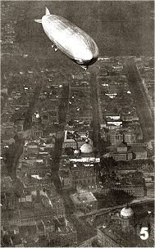  LZ 127 over Berlin |  | Radio service on airships  The radio equipment on board had a special share in the success of the American and world voyages of the airship "Graf Zeppelin", without which the whole project of long-distance journeys would have been impracticable. Therefore, on the "Deutschlandfahrt" of the airship, the range and reliability of the radio equipment were first tested by extensive practical experiments, and it turned out that they fulfilled all the requirements that necessarily had to be met by this company.  For the navigation of the airship, the radio station played just as important role as compass, altimeter and other instruments. The radio station also had to fulfill the task of keeping the airship in connection with a ground station and - by sea - with large passenger steamers.  The one of the 1st radio officer Dumcke, the last of the radio station of the HAPAG passenger steamer "New York"Board, led radio station of the airship was staffed with three radio officers and was at that time as the largest radio equipment, which had been built for this date for aircraft. For the processing of regular telegram and telephony traffic, a tube transmitter of one kilowatt of machine power (about 140 watts of antenna power) was used, which could transmit both undamped and tonally modulated telegraphy and telephony at all wavelengths between 500 and 3000 m.

The power source was a propeller generator, which was driven by the air flow while driving. He had a regulation that compensated for any fluctuations in the electrical energy delivered. Through a second air flow generator, the ship's lighting battery was powered and created at the same time a spare machine unit. A sufficiently large accumulator battery could be charged in an emergency by the installed in the guide nacelle gasoline unit. An emergency transmitter with 70 watt antenna power for telegraphy and telephony, on the wavelengths 300 m to 1 300 m, could be fed either by the generators or batteries.  Right: First radio equipment of the LZ 127 "Graf Zeppelin" |  | 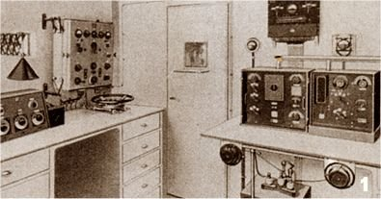

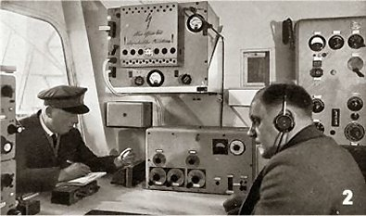 |  | The main antenna was made of two wires, each 120 meters, which were weighted at the end by a lead weight. They could be drained with an electric motor or by a hand-driven reel. A 40 m long wire, which was clamped to a ring of the airship body, served as an emergency antenna.  The reception was attended by three high-quality, armored three-track tuned receivers, each with 6 tubes, which were set up for the wavelengths 120 m to 1200 m, 400 m to 4000 m and 3000 m to 25 000 m.  A shortwave receiver, which covered the wave range from 10 m to 280 m, completed the reception system.  Left: The reception system of the LZ 127 (from 1929/30)

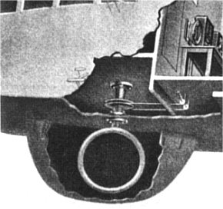 |  | For Peilzwecke served a modern Telefunkenpeiler, which was already introduced on all large passenger steamers for the direction determination. By self-bearing, by means of the rotating loop antenna, it was possible to determine the exact location of the airship from the airship, according to the principle of Kreuzpeilungen, the location of two well-known coastal radio stations or two ocean steamers whose cutlery was fed wirelessly to the zeppelin.  DEBEG had taken over the operation of the radio station. First and foremost it should be available to the needs of the ship's command, that is to say for bearings, the recording of weather reports and the timekeeping service, arrival reports, etc. In addition, she had also taken over the transport of private passenger and press reports.  The rotatable bearing frame was  mounted in a dome under the nacelle.  (Photo by LZ 126)

During the first American voyage of the airship to the United States, the radio plant processed 484 private logs with 10454 words and 160 press telegrams with 8395 words; In addition, the very extensive weather and security service. The "New York Times" of 16 October 1928 brought a description of the station under the heading "Radio on Zeppelins like plant on liner" and closed its detailed consideration with the words: "According to experts, the equipment on the" Graf Zeppelin " is the most complete ever installed in such a craft and compares in capacity with that of a modern transatlantic liner ".  As regards the results of operations with the short-wave system of the airship "Graf Zeppelin" on the world voyages carried out in 1929, the traffic ranges were used, which brought the most experience in this respect. The operating shafts used were the 35.4m, 25m, and 16.5m by day and 53m by night. Between 27m and 30m the reception was unfavorable, as strong local disturbances were observed in this area. |  | 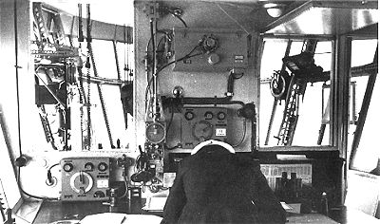  View through the map room into the command  bridge Picture taken after 1936, as the direction finding system for controlling the landing mast is already  installed here

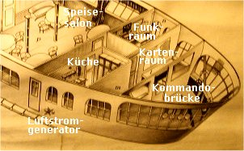 |  | With the shortwave transmitter, it was possible to reach distances of up to 6,000 kilometers at night, with great regularity. About the shortwave reception can be said that in the airship not remotely made the same difficulties as in the plane. The local noise level of electrical and mechanical causes is much lower, which is explainable, considering that the distance between the receiver and the next explosion engine was about 30 meters, so that the ignition noise played a much smaller role than on the plane. Also, it was much easier in the airship to provide all electrical apparatus with protective chokes to lower the high-frequency noise level. The resulting increase in weight played a minor role in the airship.  The gondola of the LZ 127

The acoustic noise level was also very low compared to the aircraft, since, as already mentioned, the engines were far away from the KW receiver and the radio cabin could be built with acoustically well insulated walls.

Version: 23-Nov-02 / Rev .: 14-Aug-06/11-Jun-11 / HBu

