The Bris should perhaps be called a reflector and not a sextant since it can reflect all angles.
This is an attempt to create a system of Sun position line navigation based upon the Bris reflector. The system has not considered high or low latitudes although it should be usable in the tropics.
We want that sighting opportunities should be fairly frequent throughout the day. To do this we need a fairly evenly spaced set of angles from a low, say 5° to 90°. We define these as the Least Angle L and Maximum Angle M.

The angles
The workings of the Bris are analysed in “Easily Constructed Mini Sextant demonstrates Optical properties by Garet G.Nenninger, The Physics Teacher April 2000”. The variables that can be affected are the angles between the 1st and 2nd surface angle A and 1st and 3rd surface angle B. These have been re-ordered in table 1 from the referenced article to show the smallest to largest. “Steps” in Table 1
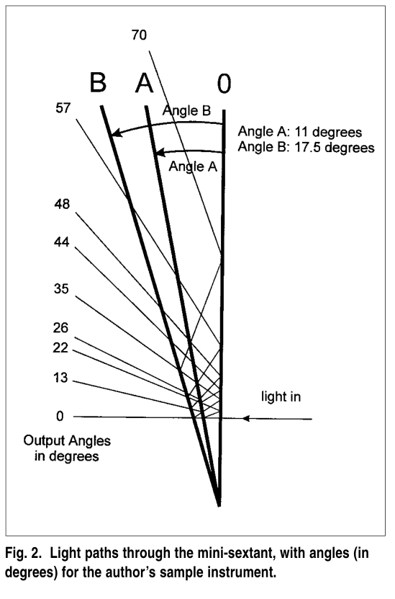
1Diagram from above article – note different angles used
Steps 1,2,4 are much stronger than the other five. It is assumed here that all eight steps are usable.

Angle A |  | 13.5
Angle B |  | 22.5
Step | Number of reflections | Image Angle | Output Angle
1.0 | 2.0 | 2B-2A | 18.0
2.0 | 2.0 | 2A | 27.0
3.0 | 4.0 | 4B-4A | 36.0
4.0 | 4+2 | 2B | 45.0
5.0 | 4.0 | 4A | 54.0
6.0 | 4+4 | 4B-2A | 63.0
7.0 | 4+4 | 2A+2B | 72.0
8.0 | 4.0 | 4B | 90.0

 |  | Angle used
Angle A |  | 13.5
Angle B |  | 22.5
Step | Number of reflections | Image Angle | Output Angle
1.0 | 2.0 | 2B-2A | 18.0
2.0 | 2.0 | 2A | 27.0
3.0 | 4.0 | 4B-4A | 36.0
4.0 | 4+2 | 2B | 45.0
5.0 | 4.0 | 4A | 54.0
6.0 | 4+4 | 4B-2A | 63.0

Rather than taking arbitrary angles A, B we would like to generate known Maximum M and Minimum L output angles. From Table 1 we see:
M=4B and L=2B-2A so for a desired M, B=M/4 ……………………..(a)
And so L=M/2-2A rearranging for A=(M/2-L)/2 ………………………..(b)
This lets us choose A and B so as to fix either the Minimum or Maximum angle.
However, the intervals may not be evenly spaced and may not occur in order of size which could cause confusion. As we have fixed M & L then the range of angles will be M-L.
L=2B-2A so range M-L=4B-(2B-2A) so M-L=2B+2A ………………………………(c)
To achieve an even spacing, or as close as possible, the range needs to be divided into the 7 intervals between the 8 Steps. Therefore, this interval needs to be (2B+2A)/7……………………………. (d)
From Table 1 we can calculate the values of each interval in the range in terms of A,B and can equate this with the desired interval in (d)
Table 2Interval values for best spread
Interval | Value | Solving against 2B+2A)/7
2-1 | 4A-2B | A=8B/13
3-2 | 4B-6A | A=13B/22
4-3 | 4A-2B | A=8B/13
5-4 | 4A-2B | A=8B/13
6-5 | 4B-6A | A=13B/22
7-6 | 4A-2B | A=8B/13
8-7 | 2B-2A | A=B

This shows that we cannot get equal intervals but that the spacing is determined by the ratio of A to B which we will call the Spacing Factor S. Note – we could try discarding the different 8-7 interval which would allow 6 fairly equal intervals. In this case the position of step 8 could be erratic so we’ll accept the gap in interval 8-7.
However, 8/13=0.61 and 13/22=0.59 so apart from interval 8-7 we can achieve near equal spacing on the first 6 intervals by making S =6/10 and using this in A=S*B we get A=3B/5………………………………..(e)
From (a) B=M/4 , substitute (e) 10A/6=M/4 : A=((6/10)*M)/4 : A=3M /20………………………..(f)
So, from a desired M and L with fairly even intervals between the first seven reflections, we now have:
B=M/4 from (a) and A=3M/20 from (f) - Note that this relationship is arbitrary since we picked the value of “S” as a convenient average.
For given angles M, L the requisite values of A, B and the output angles with differences between them are given by the spreadsheet. It would be different if we altered “S” the interval spacing.

 |  | Angle used
Angle A |  | 13.5
Angle B |  | 22.5
Step | Number of reflections | Image Angle | Output Angle | Interval | Interval angle
1.0 | 2.0 | 2B-2A | 18.0
 |  |  |  | 4A-2B | 9.0
2.0 | 2.0 | 2A | 27.0
 |  |  |  | 4B-6A | 9.0
3.0 | 4.0 | 4B-4A | 36.0
 |  |  |  | 4A-2B | 9.0
4.0 | 4+2 | 2B | 45.0
 |  |  |  | 4A-2B | 9.0
5.0 | 4.0 | 4A | 54.0
 |  |  |  | 4B-6A | 9.0
6.0 | 4+4 | 4B-2A | 63.0
 |  |  |  | 4A-2B | 9.0
7.0 | 4+4 | 2A+2B | 72.0
 |  |  |  | 2B-2A | 18.0
8.0 | 4.0 | 4B | 90.0

So we can now establish angles A and B to set known least and maximum output values that are spaced evenly in order of size (apart from the gap in interval 8-7).
The size of the interval between the first 7 steps is either 4A-2B or 4B-6A so if we use the Spacing factor S=6/10 from (e ) as above in either interval then B=5A/3 ………………………………………(g)
Substituting for B using (g) in each interval gives both interval 4A-2B or 4B-6A equal to 2A/3
For the 8-7 step interval of 2B-2A using the same method we get a value of 4A/3
So now we can set A, B to give a known Minimum and Maximum value with known intervals. We can also simplify since we have fixed B in terms of A and express all angles just in terms of A (for a given Spacing factor S).

Angle A |  | 13.5
Angle B |  | 22.5
Step | Number of reflections | Image Angle | Output Angle | Interval | Interval angle | Angle in terms of A using (g) | Interval in terms of A using (g)
1.0 | 2.0 | 2B-2A | 18.0 |  |  | 4A/3
 |  |  |  | 4A-2B | 9.0 |  | 2A/3
2.0 | 2.0 | 2A | 27.0 |  |  | 6A/3
 |  |  |  | 4B-6A | 9.0 |  | 2A/3
3.0 | 4.0 | 4B-4A | 36.0 |  |  | 8A/3
 |  |  |  | 4A-2B | 9.0 |  | 2A/3
4.0 | 4+2 | 2B | 45.0 |  |  | 10A/3
 |  |  |  | 4A-2B | 9.0 |  | 2A/3
5.0 | 4.0 | 4A | 54.0 |  |  | 12A/3
 |  |  |  | 4B-6A | 9.0 |  | 2A/3
6.0 | 4+4 | 4B-2A | 63.0 |  |  | 14A/3
 |  |  |  | 4A-2B | 9.0 |  | 2A/3
7.0 | 4+4 | 2A+2B | 72.0 |  |  | 16A/3
 |  |  |  | 2B-2A | 18.0 |  | 4A/3
8.0 | 4.0 | 4B | 90.0 |  |  | 20A/3

Caution: unless we can build the reflector with accurate Angles A and B we won’t achieve this exactly.
Next, we need a spread of reflected angles between L and M that will allow us to take a sight at reasonably frequent time intervals. Taking the extreme case that we were at the Equator then M=90° and the range will be 90° also. Given that, in this case we will have 12 hours of daylight with 6 hours rising and 6 hours setting so we can use the same values and need cover only 6 hours.
We want, say, 10 chances per hour to take a sight. Assume, for simplicity, that the Sun’s altitude changes at a regular rate. Then we’d need an output angle or “step” every 90/60=1.5° For higher latitudes the range will be lower but the daylight hours longer with the range per hour, generally, lower.
Assuming that all 8 output angles are usable then this would require 60/8=8 reflector units.
However, each reflection of the Sun can be used as Upper, Centre or Lower limb which will cover one Solar diameter of about 0.5° So in principle 60 steps could cover the whole 90° range. This is, however, unlikely to be achievable.
For practical reasons 4 units are chosen, referred to as a,b,c,d..
If we have several units we need to know how to relate the step increase between unit n and unit n+1 if we want to increase the first step by X.
For unit 1 Angle 1 is 4A/3, if we add X to A then for unit 2 Angle 1 becomes 4(A+X)/3 and the incremental change is therefore 4(A+X)/3-4A/3 which reduces to X/3.
To get an even distribution across n units we could try using increments of the interval 2A/3 divided by n X=2A/3n…..(h) (This was abandoned as trial and error gave a better result)
Best so far is this:

 | For four units
Minimum | L | 18.0 | 15.5 | 8.0 | 3.4
Maximum | M | 90.0 | 77.5 | 40.0 | 17.0
 | A | 13.5 | 11.6 | 6.0 | 2.6
 | B | 22.5 | 19.4 | 10.0 | 4.3
 | Step | A | B | C | D
 | 1 | 18.0 | 15.5 | 8.0 | 3.4
 | 2 | 27.0 | 23.3 | 12.0 | 5.1
 | 3 | 36.0 | 31.0 | 16.0 | 6.8
 | 4 | 45.0 | 38.8 | 20.0 | 8.5
 | 5 | 54.0 | 46.5 | 24.0 | 10.2
 | 6 | 63.0 | 54.3 | 28.0 | 11.9
 | 7 | 72.0 | 62.0 | 32.0 | 13.6
 | 8 | 90.0 | 77.5 | 40.0 | 17.0
This gives the following spread. It does not have values below 3 but these would be low sights anyway. The intervals are sparse above 45 although this could be adjusted. The Coverage % value gives an indication of the proportion of time that a sight would be possible up to that altitude and this averages 28% for the range. Consequently, one should not have to wait too long to take a sight.
 | Step | Ref | Value | Interval | Lower limb | Centre | Upper limb | Coverage | Cumulative coverage | Coverage %
 |  |  |  |  | 0.0
Unit d | 1 | d1 | 3.4 |  | 3.2 | 3.4 | 3.7 | 0.5 | 0.5 | 14%
Unit d | 2 | d2 | 5.1 | 1.7 | 4.9 | 5.1 | 5.4 | 0.5 | 1 | 19%
Unit d | 3 | d3 | 6.8 | 1.7 | 6.6 | 6.8 | 7.1 | 0.5 | 1.5 | 21%
Unit c | 1 | c1 | 8 | 1.2 | 7.8 | 8.0 | 8.3 | 0.5 | 2 | 24%
Unit d | 4 | d4 | 8.5 | 0.5 | 8.3 | 8.5 | 8.8 | 0.5 | 2.5 | 29%
Unit d | 5 | d5 | 10.2 | 1.7 | 10.0 | 10.2 | 10.5 | 0.5 | 3 | 29%
Unit d | 6 | d6 | 11.9 | 1.7 | 11.7 | 11.9 | 12.2 | 0.5 | 3.5 | 29%
Unit c | 2 | c2 | 12 | 0.1 | 11.8 | 12.0 | 12.3 | 0.5 | 4 | 33%
Unit d | 7 | d7 | 13.6 | 1.6 | 13.4 | 13.6 | 13.9 | 0.5 | 4.5 | 32%
Unit b | 1 | b1 | 15.5 | 1.9 | 15.3 | 15.5 | 15.8 | 0.5 | 5 | 32%
Unit c | 3 | c3 | 16 | 0.5 | 15.8 | 16.0 | 16.3 | 0.5 | 5.5 | 34%
Unit d | 8 | d8 | 17 | 1 | 16.8 | 17.0 | 17.3 | 0.5 | 6 | 35%
Unit a | 1 | a1 | 18 | 1 | 17.8 | 18.0 | 18.3 | 0.5 | 6.5 | 36%
Unit c | 4 | c4 | 20 | 2 | 19.8 | 20.0 | 20.3 | 0.5 | 7 | 35%
Unit b | 2 | b2 | 23.25 | 3.25 | 23.0 | 23.3 | 23.5 | 0.5 | 7.5 | 32%
Unit c | 5 | c5 | 24 | 0.75 | 23.8 | 24.0 | 24.3 | 0.5 | 8 | 33%
Unit a | 2 | a2 | 27 | 3 | 26.8 | 27.0 | 27.3 | 0.5 | 8.5 | 31%
Unit c | 6 | c6 | 28 | 1 | 27.8 | 28.0 | 28.3 | 0.5 | 9 | 32%
Unit b | 3 | b3 | 31 | 3 | 30.8 | 31.0 | 31.3 | 0.5 | 9.5 | 30%
Unit c | 7 | c7 | 32 | 1 | 31.8 | 32.0 | 32.3 | 0.5 | 10 | 31%
Unit a | 3 | a3 | 36 | 4 | 35.8 | 36.0 | 36.3 | 0.5 | 10.5 | 29%
Unit b | 4 | b4 | 38.75 | 2.75 | 38.5 | 38.8 | 39.0 | 0.5 | 11 | 28%
Unit c | 8 | c8 | 40 | 1.25 | 39.8 | 40.0 | 40.3 | 0.5 | 11.5 | 29%
Unit a | 4 | a4 | 45 | 5 | 44.8 | 45.0 | 45.3 | 0.5 | 12 | 27%
Unit b | 5 | b5 | 46.5 | 1.5 | 46.3 | 46.5 | 46.8 | 0.5 | 12.5 | 27%
Unit a | 5 | a5 | 54 | 7.5 | 53.8 | 54.0 | 54.3 | 0.5 | 13 | 24%
Unit b | 6 | b6 | 54.25 | 0.25 | 54.0 | 54.3 | 54.5 | 0.5 | 13.5 | 25%
Unit b | 7 | b7 | 62 | 7.75 | 61.8 | 62.0 | 62.3 | 0.5 | 14 | 22%
Unit a | 6 | a6 | 63 | 1 | 62.8 | 63.0 | 63.3 | 0.5 | 14.5 | 23%
Unit a | 7 | a7 | 72 | 9 | 71.8 | 72.0 | 72.3 | 0.5 | 15 | 21%
Unit b | 8 | b8 | 77.5 | 5.5 | 77.3 | 77.5 | 77.8 | 0.5 | 15.5 | 20%
Unit a | 8 | a8 | 90 | 12.5 | 89.8 | 90.0 | 90.3 | 0.5 | 16 | 18%
 |  |  |  |  |  |  |  |  | Average | 28%

Construction
An interesting approach is to halve the number of reflectors by adopting the ingenious “Butterfly/Dragonfly” system of Greg Rudzinski. This, in theory means we could manage the whole range with only two double reflector units.
Note – now there is the “stack” idea by Peter Monta.
Filters……
Two 49mm polarised filters threaded together. This size chosen as I have a plain 48-49mm adaptor that might be useful for mounting. Rotating one gives variation in shade and seems OK. A clear/UV filter could be added and made the prime surface of the reflector ( as per Greg.R)
Microscope Cover Glass 24x24mm – not yet tried this, they are very thin, might be good for shims.
Case…..not done yet.

Calculation of sights
Sights can be reduced by any of the normal methods. However, this system aims to to provide an easy Line of Position Navigation system for short passages by sailing yacht. Given this restriction it should be possible to pre-calculate a table for each possible value in the defined area of the passage.
We should know the Date, Departure and Destination point. Height of eye can also be fixed. As the Sun must be in the sky then, in mid latitudes it will be in the sky for, at most just over 16 hours. Assuming a net boat speed of seven knots (tides will most probably balance) then at most 112 nM will be travelled in this period which is less than two degrees of Latitude or Longitude. Consequently, we could choose two or three Assumed Positions, which should fit conveniently with the charts to be used. These could be the Departure, Destination and a point in the middle. Sensibly these would be on a land/sea mark or an intersection on the chart such as a whole degree of Latitude and a 5’ or 10’ Longitude.
For each of these positions for each, say, 15 minutes of time between Sunrise and Sunset (around 48 values according to Latitude) we can calculate the Altitude, Hc and Azimuth, Zn and SD of the Sun. We then adjust this to an observed centre body reading using Height of eye for dip and calculating refraction.
This Ho reading is compared with the list of Bris reflector steps (for four units this will be 32 in total). Second and third comparison passes are made for upper and lower limb. Those steps which are within, say 40 arcminutes are considered viable. For each viable step the Step reference a-d, limb (upper, centre, lower) and intercept are recorded against the time. The process is repeated for the other Assumed positions.
Lide Brooks produced an almanac type spreadsheet based on Meeus (Brilliant piece of work thanks). This has been incorporated into a spreadsheet to build tables on the above system. Not finished but seem so work so far. Using this we consult the nearest time slot for an Assumed position and determine for that Unit/Step/Limb the Azimuth and intercept. We can then draw the Line of Position in the usual manner. For each time entry a correction to the intercept will need to be applied for each minute that the time of sight is in excess of the time given. Azimuth can be interpolated by inspection. Reciprocal Azimuths given for away intercepts.
Sample below for one AP using 5 minute time slots:-
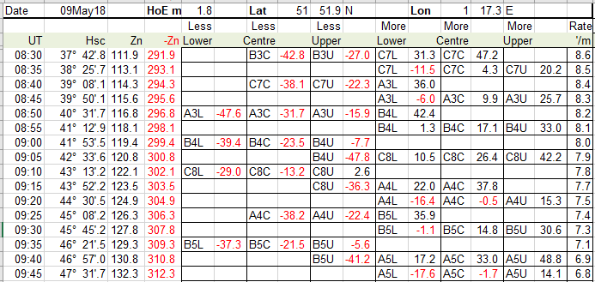

The Reflectors above A,B,C,D are fictional as I have not yet perfected getting the angles I want. The values are:
Sorted by angle | Sorted by Reflector Unit
Value Ref  0  10.00 D1  11.50 D2  13.00 D3  14.50 C1  16.00 D4  17.50 D5  19.00 D6  20.50 C2  22.00 D7  23.50 B1  25.00 C3  26.50 D8  28.00 A1  29.50 C4  31.00 B2  32.50 C5  34.00 A2  35.50 C6  37.00 B3  38.50 C7  40.00 A3  41.50 B4  43.00 C8  44.50 A4  46.00 B5  47.50 A5  49.00 B6  50.50 B7  52.00 A6  53.50 A7  55.00 B8  56.50 A8 | Value Ref  28.00 A1  34.00 A2  40.00 A3  44.50 A4  47.50 A5  52.00 A6  53.50 A7  56.50 A8  23.50 B1  31.00 B2  37.00 B3  41.50 B4  46.00 B5  49.00 B6  50.50 B7  55.00 B8  14.50 C1  20.50 C2  25.00 C3  29.50 C4  32.50 C5  35.50 C6  38.50 C7  43.00 C8  10.00 D1  11.50 D2  13.00 D3  16.00 D4  17.50 D5  19.00 D6  22.00 D7  26.50 D8

