I’ve been asking to provide more details about my Mark-IX-A bubble sextant calibration station and methodology. I will try to be as clear as possible though you’ll have to forgive me for my approximative English that will sound less than perfect. Sorry for those who will find it hard to follow but I will do my very best to be as clear as possible without being to rude on your ears.
My goal by doing such station was to be able to easily adjust with confidence my bubble sextant mirror calibration in a standard home environment without fancy tools or devices. Nevertheless, it as required a lathe and a good friend to machine a Mark-IX housing replica from an aluminum bloc (7 X 7 X 2 inches). I had provided a schematic file attach to this post for those interested. The general idea is to put a laser guide into this sextant housing replica as a reference level to indicate the index mirror center. Once done, your laser will guide you to position a light emitting diode (LED) at the opposite end of the room as a 0° level reference. After the led is in place, you remove the laser housing and place your sextant in position for calibration.
To maintain an adequate position when switching units, you will have to build a base template support with a sextant bottom shape on which you will be able to substitutions your laser housing by the sextant to be calibrated in exact position. This base support will be lying on a surface that is already known to be at 0° horizontal level. Usually, kitchen counters are a good place if they were correctly installed. You will have to validate and correct its horizontal level accuracy before proceeding further on. Once done, this surface will support your template base to perfectly position horizontally your sextant each time you calibrate. Notice that this base support as also to be considered in the right left level adjustment so the bubble will appear correctly in the center of the eyepiece window lens. Remember that the sextant will have to be place on the counter edge for you to be able to look true the eyepiece window to confirm your adjustment. This support should have a moulding on one side to maintain its alignment with the counter edge so the distance between the sextant base and LED apparatus will be preserved, even if overlapping requires a small side displacement on the counter. This moulding will help you overlap the led and bubble images without affecting the distance or elevation between mirror and Led apparatus.
Now, to achieve such setup with a suitable accuracy, you will need to be meticulous. The first step is to fabricate the housing template in order to locate the exact index mirror center positioning. The industrial drawing file provided here will facilitate you the job. The aluminum bloc as 3 reference faces. Front, left and bottom planes are the references from which all positions had been determined for the housing replica measurements. I also have managed to tap treads on the template side align with the rotation mirror center axe so a bolt could be place and use as a tape holder to help measurement operations. This will ease accuracy between the sextant mirror center exact position and the reference level LED apparatus. The housing template as also a front hole that have been drill exactly in the index mirror horizontal center orientation for a standard riffle laser bore to be inserted. Such laser can be bought on Ebay for less than $20. These lasers are usually installed to adjust a riffle telescope to target and are position into the riffle canon to point out the presume bullet trajectory. These lasers are not as accurate as others like those needed to fine tune a star telescope mirror for exemple but are far less expensive and easier to adapt to a different application. The accuracy provide by this kind of laser could be significantly improve with a few additional interventions to reach a fairly good calibration standard.

Here is a picture of the needed equipment that you will have to built in part.
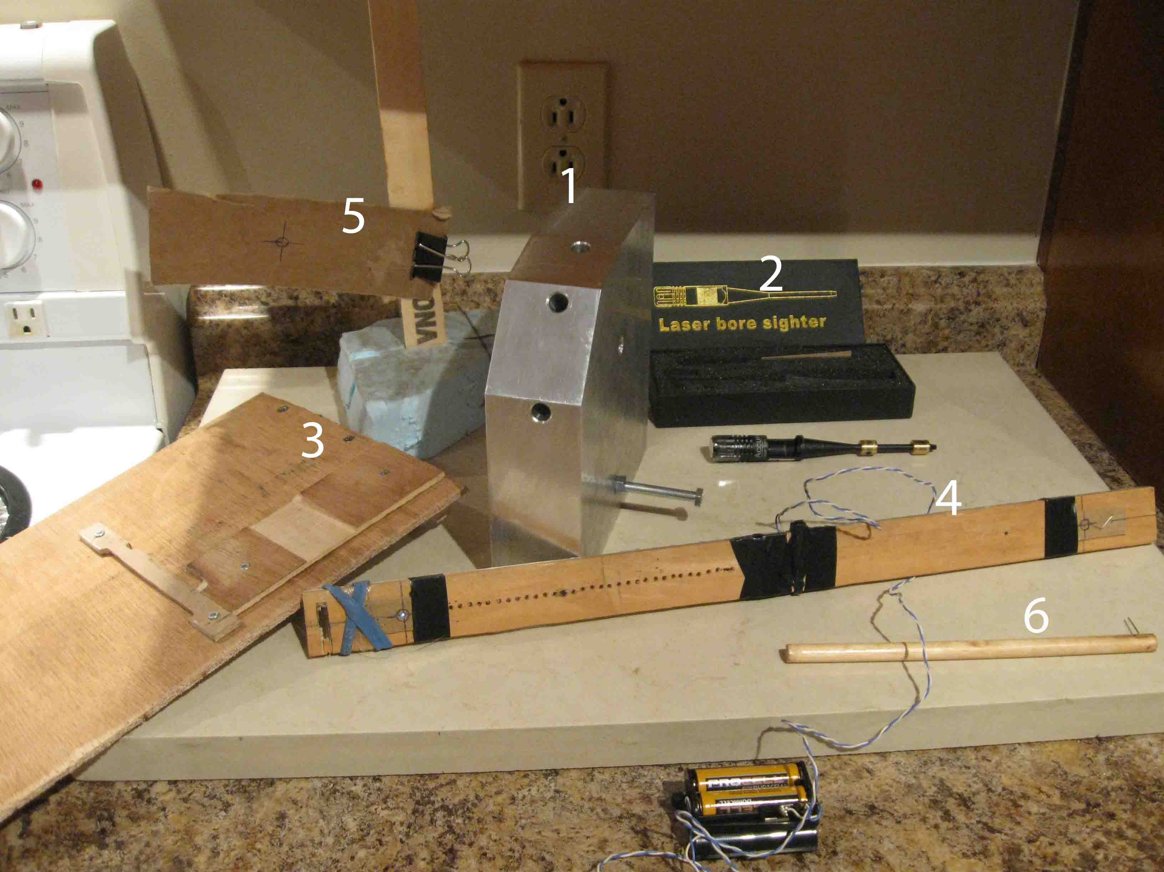
- Mark-IX sextant housing replica template (laser holes are drilled at 0°, 40° and 80° of elevation along center mirror rotation position
- Riffle laser bore
- Base support template
- Led support apparatus with batterie housing at the end of the wire
- Target support for fine tuning (place manually)
- Wood stick tool with a perpendicular needle at one end (use to turn adjustment screws)

First thing we considered was to replace plastic tips provided by the laser manufacturer. These tips are use to align the laser tail end within the diameter of the riffle canon. However, these tips a cheap plastic and tended to broke. We made two copper rings to be fix to the laser bore tail in order to keep its perfect alignment within its housing hole when the conic laser head sits perfectly in place. These copper rings could be seen on the above picture (item #2) already fix to the laser tail end.
To further improve accuracy, we also have covered the laser beam hole with a sheet of paper that as been tape not to move and in which a little hole the size of a needle was made and centered to the laser output hole. This restriction will reduce the spreading ray of light from the laser beam to fall around ½ of an inch 15 feet away.
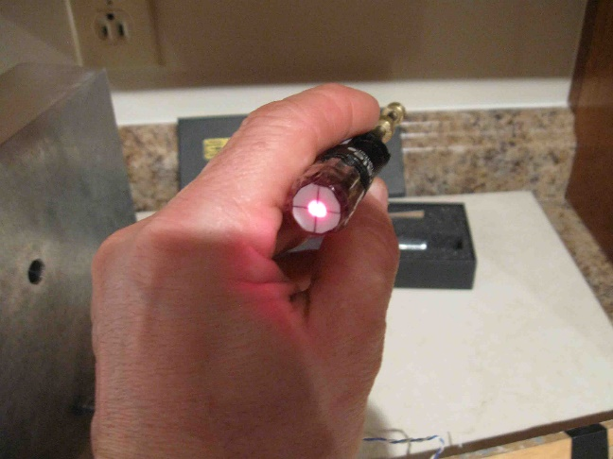
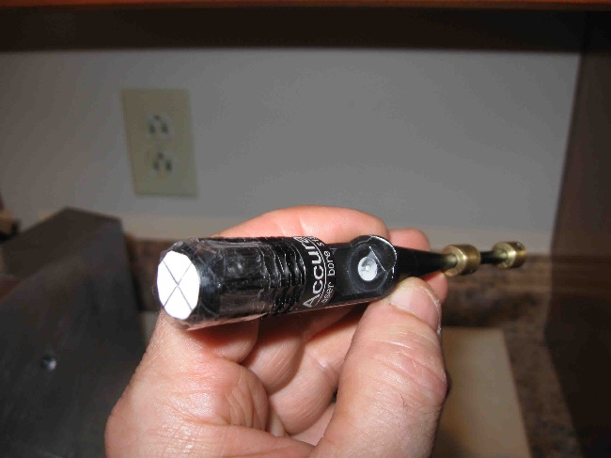
The laser beam output was covered with a piece of paper which had a needle hole in its center. Once the light on, only the ray passing true the needle hole will reach the other end of the room.

To comfort accuracy again, I have done two more operations to determined the most probable mirror center position. If the laser was than perfectly aligned with the center hole when sitting in place, you should be able to rotate it on itself manually and see its laser spot the other side of the room wall turn on itself, without doing a circle trajectory.
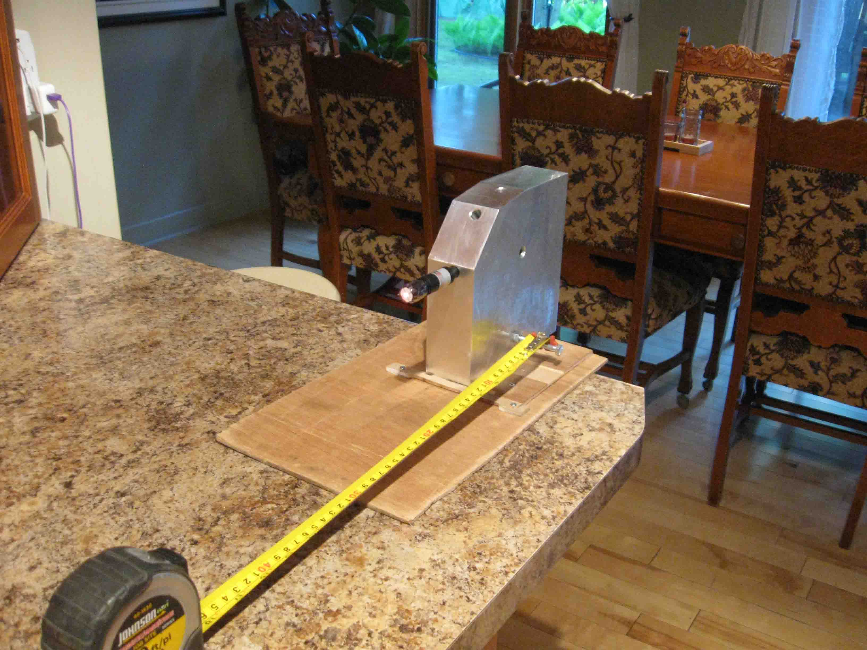
You can see the tape holder to help measure the distance between mirror center position and the LED apparatus.
This will not be the case and the red spot will follow a circle trajectory on the wall. So, the most probable position for the mirror center level to be located is in the center of this small circle. Put a cardboard on the wall or a piece of paper and draw the circle by hand to position its center location. This center will represent the most probably margin error area for the center index mirror 0° level to be place. Try to manage to have your wall circle drawing cardboard to sit on the counter so it can be put back in place for further calibration each time you installing back your station. Overtime, you will improve your 0° center reference level. For example, my first calibration attempt gave me a steady +2’ on my readings that I came to subtract in my calculations. However, in my specific setup 2 arcminutes is 2,65 mm long. I can now reposition my first center drawing attempt by moving up its center mark by 2,65 mm to correct my previous reference mark.
At this stage of the operation, hang your LEDs apparatus down approximatively in place so you can position coarsely the laser beam support to hit it. This to determine approximatively the position of all related components. I put a screw behind a cabinet sealing molding that crosses my kitchen sink to have the LEDs apparatus hook on it. The ruler is hanging over sink and the wire goes up to the screw and back down on the counter to be hold by something heavy that I have put on it as a stopper. To move up or down the LEDs, you simply release or pull the wire from its restraining weight. Once this approximatively location established, you will pull up the LEDS ruler for a while to begin determining the index mirror center height with more accuracy.
With your laser bore pointing towards this approximatively LEDS direction, you will start next step. Once this area is coarsely established, I made another control to reduce error within this specific area. I used a second cardboard with a ½ inch circle target drawing on it that as also a needle hole in its center. This target is mounted on a little stand that I could move manually. I place this second target close to the LED apparatus final estimated position (about 1 or 2 inches in front of it) and have the target center height adjusted by hand so the laser beam hits it. The laser beam as a spreading of half an inch from which I place the cardboard target center hole in what seems to be the most probable laser center location by eye. Behind this target cardboard, the ray of light left as a needle size diameter that represent the most probably accurate 0° center index mirror reference level from which LED apparatus will be centered from hole to hole.
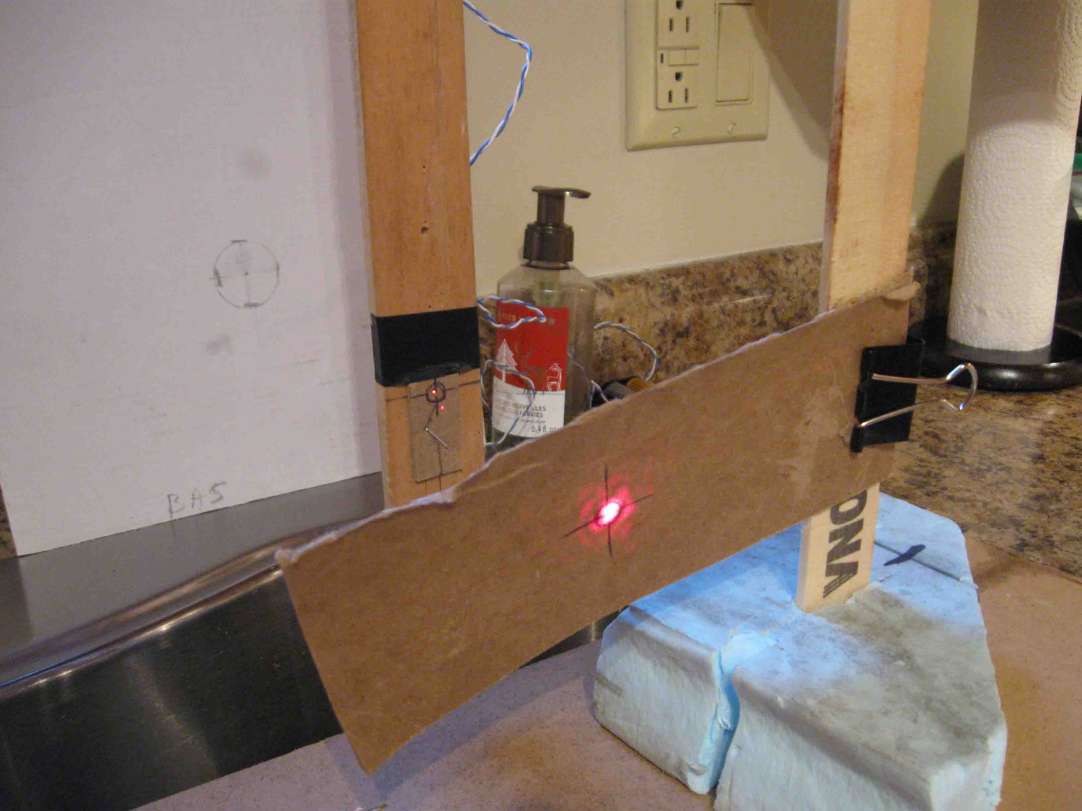
At the back against the wall is the cardboard on which the laser beam circle trajectory was drawn to determined its center height. You can also see the laser beam hitting the manual target support in front and the Led apparatus hanging behind. The upper red light on the LED apparatus as to be place at the 0 ° reference center mirror height projection which is the tinny red spot just below. This small red spot is the ray of light getting true the center needle hole of the target support. Just release the wire that holds the Led apparatus so the LED support will drop slightly until the ultimate laser reference spot touch the horizontal line drawn on the LED lid that indicates its hole alignment for the LED center. Centered both holes from hole to hole (LED apparatus hole with manual cardboard target hole) by moving vertically only the LED apparatus support and by leaving on touch the final laser beam reference level).

Before proceeding further on at this stage, you will need to build a support for two LEDs to be place apart vertically by 5° of elevation. This specific configuration is needed to adjust the 2 secondary mirror positions (0 and 5 degrees). This support will be hanging vertically at some distance with is lower LED perfectly align with your 0° mirror center reference laser beam. Mine is made from a small piece of wood that as a ruler shape. It is about 1 inch wide, 2 feet long and 1/8 inch thick. I had drill 2 holes along its center axe for LEDs to be inserted. One white LED and one red LED to help avoid mixing position during calibration. When the ruler is hanging from its wire, both LEDs will be vertically aligned. The apparatus could be pull up or down simply by playing with the wire length without changing this 5° increment between Lights. To help you with vertical alignment, just use another wire with some weight at one end that you let hang from the same holding screw. This wire will be use as a vertical gravity reference. Your LED apparatus vertical axes should be following this reference equally all along from one to the other LED.
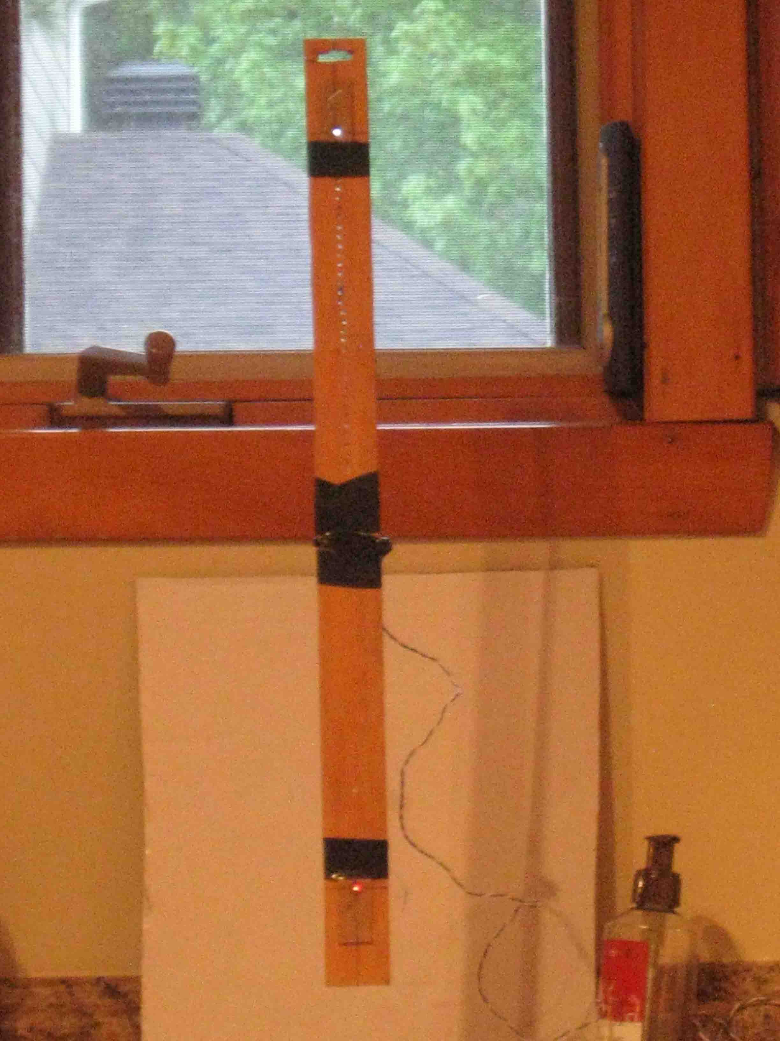
You will need some math to determine the exact distance between two LEDs to make sure you have vertically 5° of separation. These computations will depend on the distance available in your room and will have to be adjust to your specific environment. The formula is “Tang 5° X B = A where B is the distance between your sextant center mirror position and your LED support. Distance A is the length required between the LEDs on the support to get 5° of separation for your specific set up. Use a maximum available distance to increase accuracy. However, the minimum distance to be considered will be 3429 mm (135 inches or 11’ and 3”). At such distance 1 mm = 1 arcminute which I consider the tolerance limit of our material accuracy. In my case, B was 4538 mm (around 14,88 feet) which required 397 mm between the two LEDs for 5° of separation.
The LEDs could be 3 or 5 mm in diameter as long as they are super bright ones. The size is not important because you will have to cover them with a cardboard with a hole the size of a needle perfectly centered on them. This little hole will provide a ray of light so tin that it will look exactly from a certain distance as if it was a star. This hole will be aligned with the final laser beam reference hole to hole to get a final suitable 0 reference level.
You will also have to built a base template support with the sextant bottom shape on which you will be able to put your laser housing followed by the sextant to be calibrated. This base support will be lying on a surface that is already known to be at 0° horizontal level. Usually, kitchen counters are a good place if they were correctly installed. You will have to validate and correct level accuracy before proceeding further on. Once done, this surface will support your base template to perfectly position horizontally your sextant each time you will calibrate. Notice that this basic template as also to be considered in the right left level adjustment so the bubble will appear correctly in the center of the eyepiece window lens. Remember that the sextant will have to be lying on the edge of the counter for you to be able to look true the eyepiece window to confirm your adjustment. This base support will have a molding on one side to be align perfectly with the counter edge so the distance between the sextant and LEDs are preserved correctly each time.
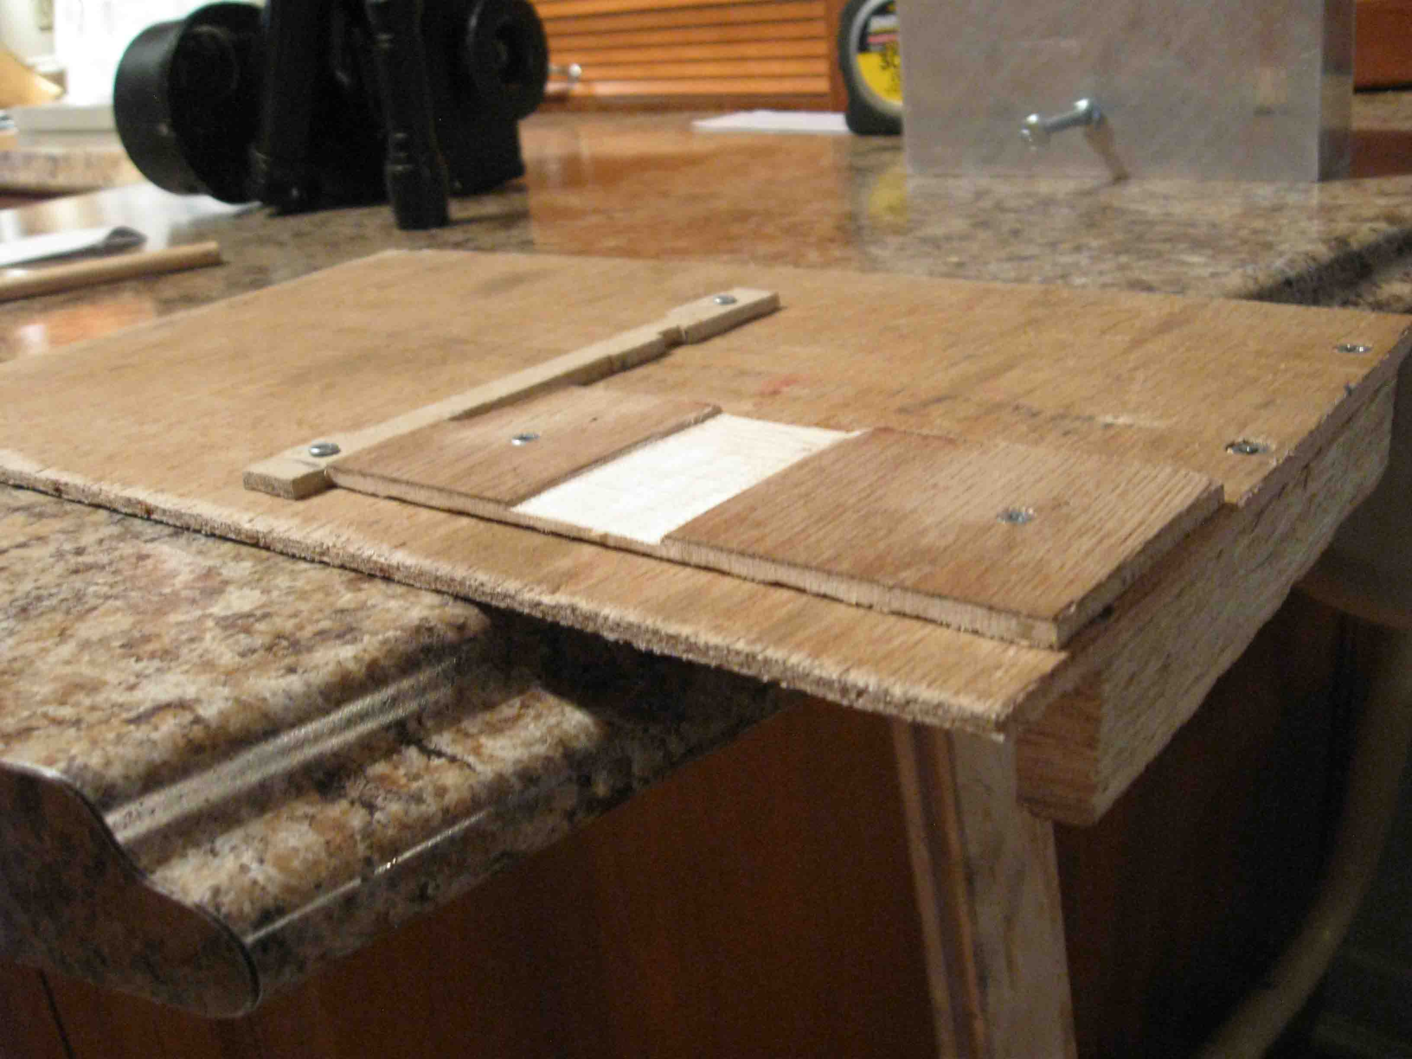
As you can see here, the base template as a rear bottom moulding that’s as to be align on the counter edge to preserve exact distance between the sextant or housing replica and the LED apparatus. It was pull off here a little so you can better see its shape. Both top parts were carved to accommodate the sextant shape with is averager unit. The large groove was crafted in order to have the left sextant handle sit correctly for the bubble to be position in the center of the eyepiece window
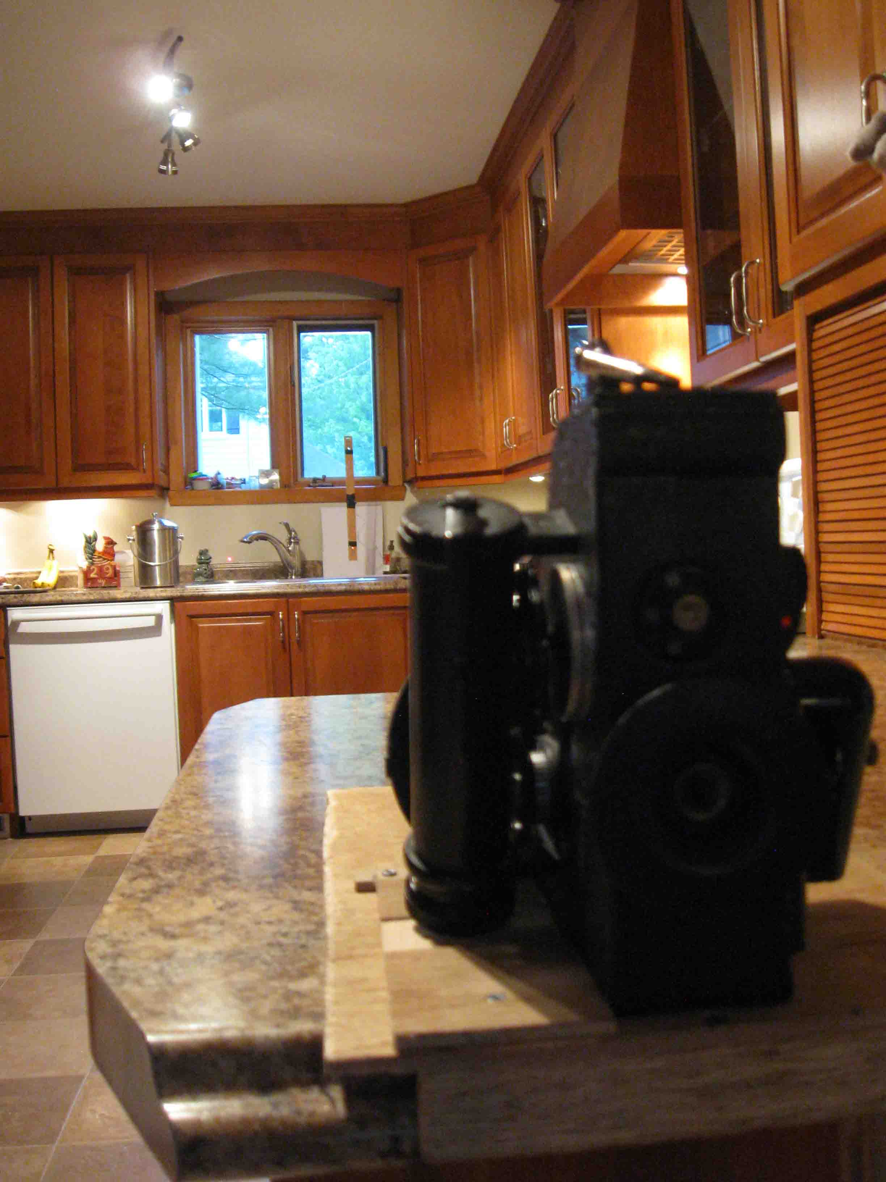
Here is the final look of my station once ready to proceed with calibration. Notice that the Sextant lies on the counter edge so you can have a look true its eyepiece window to confirm your modifications until satisfaction. Contrary to the Rolling Stones, you should get satisfaction……..

You will also need to fabricate a little tool made of a wood stick in which you have insert a perpendicular needle at one end (item #6 on first picture)). This needle will have to be exceeding out by 1 inch. This tool will be used to turn the adjustment screws that has side holes instead of a top groove without having to open the sextant housing during calibration.
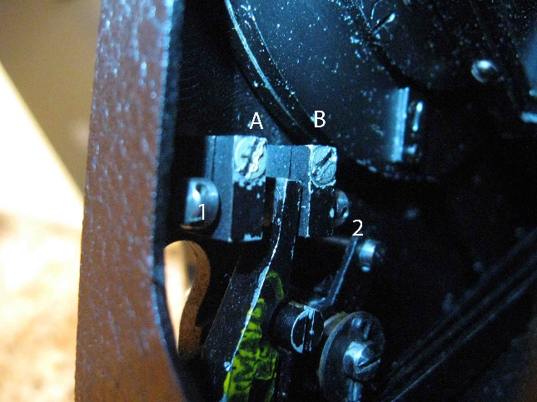
A and B are locking screws that have to be release before trying to turn adjustment screw 1 and 2. B2 set is for 0° increment and A1 for the 5° position.
The last thing before starting the calibration will be to remove all 4 case screws that are holding both housing hafts together so you can split open the sextant to get access to the locking screws and have them release before trying to play with the mirror adjustment ones. Once release you’ll have to put back together both housing hafts without replacing 4 screws until calibration is over.
To start calibration, make a bubble as usual in the bubble chamber and place the sextant at its proper place on the base support. To help you see the bubble when looking true the eyepiece window without activating shades, place a piece of paper for attenuation and use a Maglite on the top bubble chamber window so you should see your bubble and the LED with a suitable intensity.
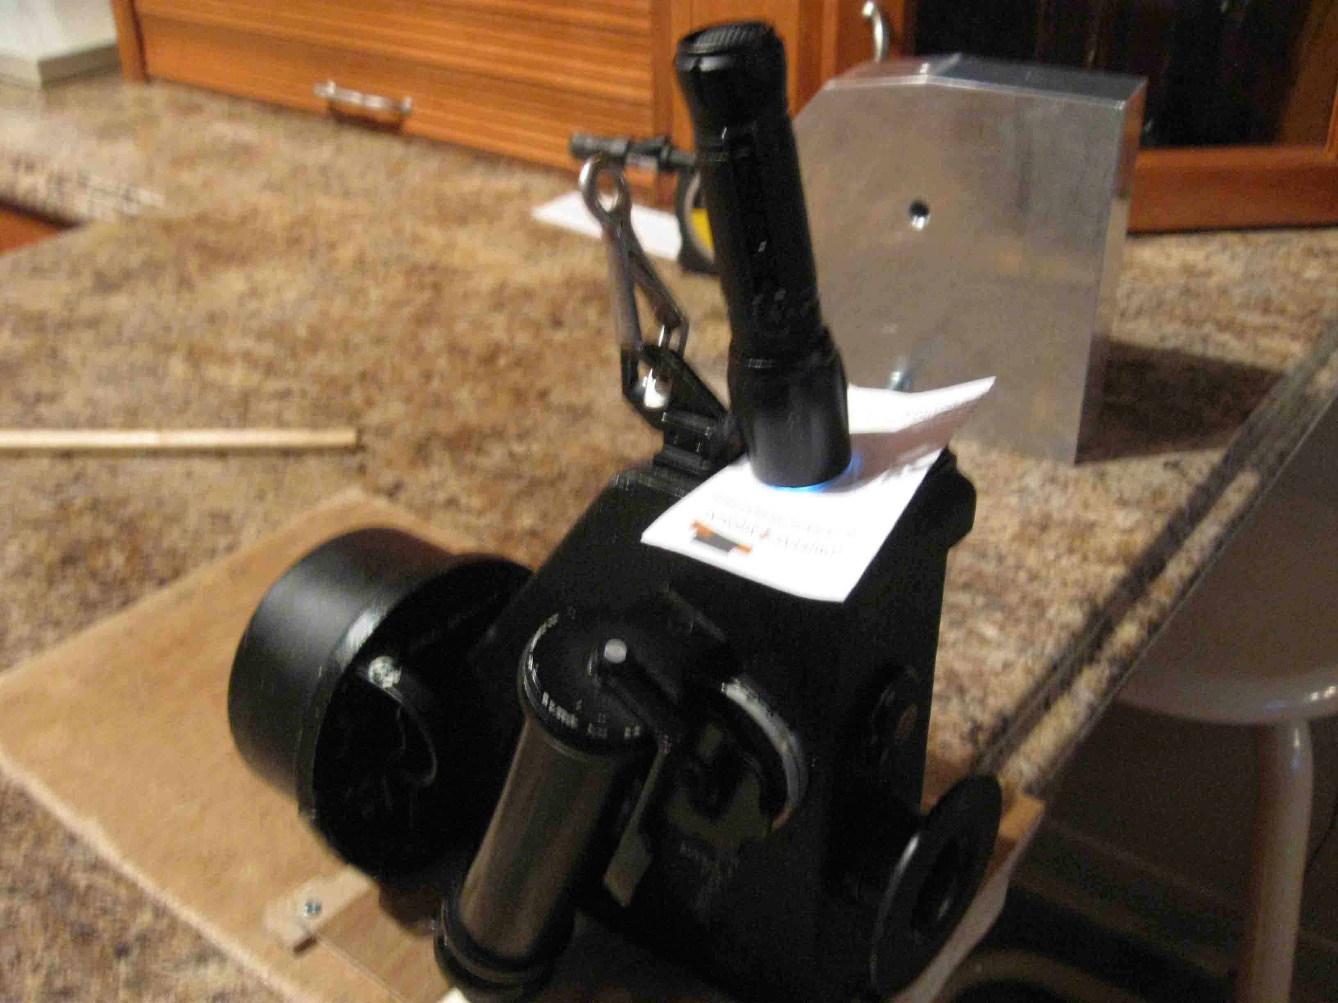

The bubble should be centered with the eyepiece window view and the LED almost horizontally align with the bubble center. If the bubble is not centered horizontally with the eyepiece window disregarding LED position, your sextant is not in a proper horizontal level condition to be calibrated. Your kitchen counter level accuracy or any horizontal plane use as a base reference would have to be check and corrected. Your base template support could also be involved and will have to be check too. Once your bubble is in the middle of the eyepiece window, align the LED by sliding slightly the base support along the counter edge so the LED will align with the bubble center vertical axes. This side displacement will keep the sextant in its proper position for calibration. The LED will be higher or lower from a horizontal center imaginary line passing true the bubble. It will have to be vertically adjusted to reach a perfect centered positioning to complete calibration. To adjust mirror, use the wood stick tool (item # 6 in my first picture) in order to reach adjustment screws from the case front opening without moving or splitting the housing haft. Put the needle into one side holes of the appropriate adjustment screw for the mirror incrementation (0 or 5 degrees) position to be calibrated.
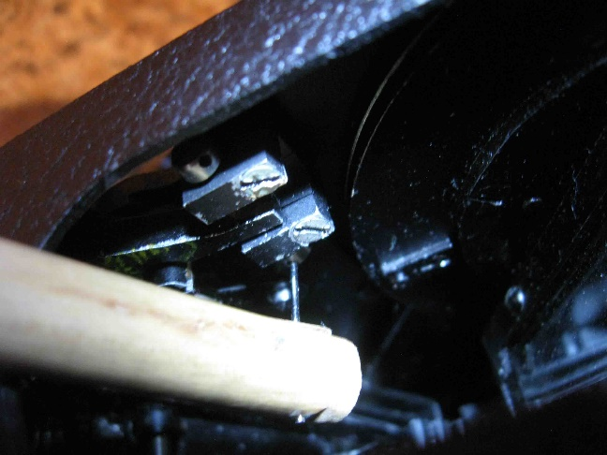
Turning the screw downward will make the LED go up in the eyepiece window view and reverse motion will bring it down. Remember that if you have to relocate your laser beam reference in a later calibration session. Moving up your 0° reference will make your further readings smaller. If your sextant needed a negative correction in your tabulation before calibration, it was because the readings were to high. You will have to reduce readings by rising up a little bit your 0° reference position. Rising up your mirror center position reduce the distance between reference level and body position. Placing the 0° reference lower will give higher readings after calibration.
Once the calibration is over, put back all 4 housing screws in place for our sextant to be ready for outdoor operations again.
Since I have built this station and played with it, I have positioned my reference level with a comfortable accuracy so my recent readings are within 00,6 arc minutes from GPS location. However, to reach such precision I have also compute an Averager run error tables to correct the mechanism variability find among various reading height. These various conditions will affect the speed of the averager when reading so the final result can be slightly off. To get such correction table, I did 5 averager run for each 9 mirror index positions (0, 10, 20, 30...up to 80 degrees) by each rounded value elevation provided by the fine setting knob (0, 1, 2, 3, up to 8 degrees of altitude). It took me 320 averager runs to complete the table. I than computed the most probable function for in between 15 arcminute steps. My actual good results seem to be possible by the mean of such methodology. Of course, you must make sure your sextant is well stabilized when running. Small tremblements such as breathing or hand shacking will drastically increase your error, often by more than 10 nautical miles.
I also made another discovery with my station that made me change my way to do readings. All my Mark-IX unit are possibly showing wearing signs. When the sextant was in place in the station and everything was calibrated correctly, the reading was not exactly right when the fine tuning knob was roll up from 0 to the desired elevation. I notice this with the 5° increment LED position readings that was always reported 12 arcminutes lower than expected. However, the LED position is spot on the 5 ° elevation arc, as calculated with math. I than tried to roll the fine tuning knob elevation from 0 to the other end of knob rotation for a maximum of elevation before scrolling down back to the 5° reference LED. Bingo, the wheel was indicating a perfect 5° of elevation each time. Since that day, I start my readings with my fine setting knob at 0 in order to place correctly my index mirror increment and position after what I turn the fine setting knob to its maximum elevation before scrolling down to the desired celestial body reading. Since I have proceeded this way, my results accuracy significantly improved.

I hope my approximative English was not to hard on you. I sincerely believe though it worth the effort to stay tune. I’m wishing you the very best for the days and nights to come by fulfilling your eyes with the most nicest view possible.

Warmest regards from upper 48

Jean Villemagne VE2CAL
N45° 44,8 W73° 38,3

