Celestial Navigation
A graphic method
Marco A. Costa
2/1/2012

A graphic method to complement more traditional ways to find your place on earth

A GRAPHIC RELATION AMONG Hc, Zn and LHA

Purpose:

The objective for developing this method was motivated by the need to find a graphical relation between the LHA (local hour angle) of a celestial body and its corresponding altitude (Hc) and azimuth (Zn).

The method intends to be used as an accessory but by no means as a substitute for more comprehensive and accurate traditional methods using reduction tables, star finders etc.

The equations have the purpose to confirm and tune up the results obtained graphically.

The author strongly encourages the acquisition of navigational skills by continuous reading and enrolling in a formal/certified training course.

The author does not assume any responsibility for any mishaps allegedly related to the use of this method. Graphics are as accurate as the tools and mastery used. So if you end up in Alaska on your way to Tahiti, not my fault buddy.

Next we’ll review a few basic concepts needed to understand how the method works:

As shown in Fig 1. The position of a point in space could be defined by three axis, “x”, “y”, and “z”. For our purposes we are going to define “x” as the North-South axis, “z” as de East-West and “y” as your Zenith-Nadir axis.

As many others have done, we are going to consider all celestial bodies projected in an imaginary sphere in which we are the center. For graphic convenience the radius of this sphere will be 60 units.

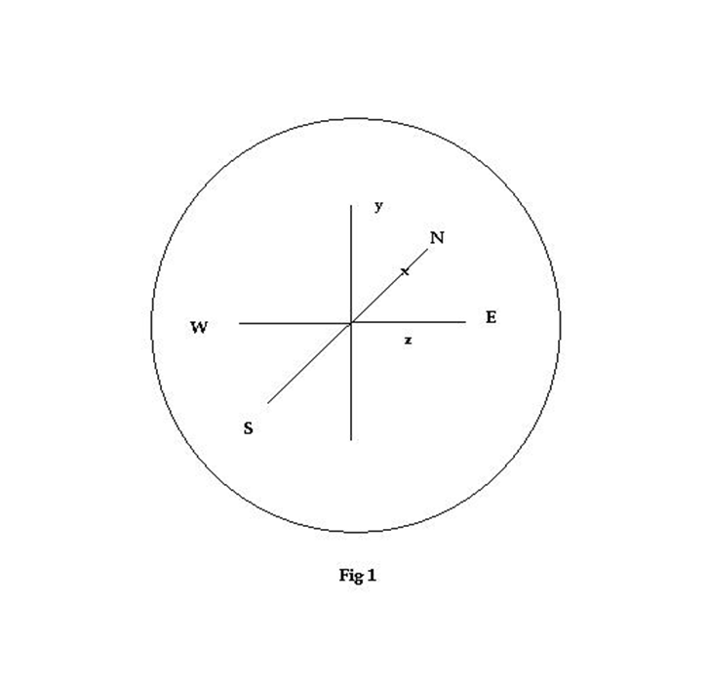

In Fig 2 a crash trigonometric review needed for this method is represented. Any questions/complaints please contact your high school math teacher. A cheap scientific calculator may come handy to solve the equations.

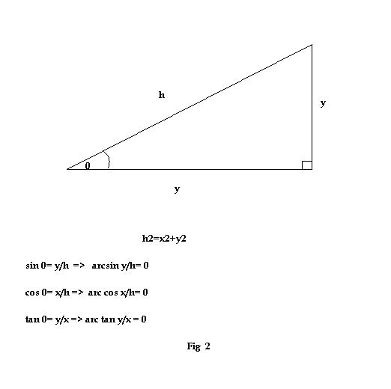

Fig 3:

Three axis representing the position of the celestial body will generate the vectors shown. The altitude angle Hc may be defined from here as:

Hc = arctan (y/ (x² + z²) ½)

And the sphere radius: r = (x²+y²+z²) ^{1/2}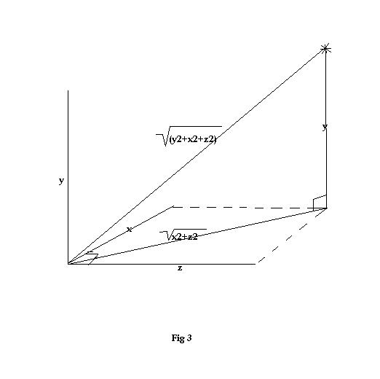

Fig 4:

From a plotting chart a sort of nautical rose is made which will be our main graphic ground. For positioning of our celestial bodies, four quadrants are defined as below.
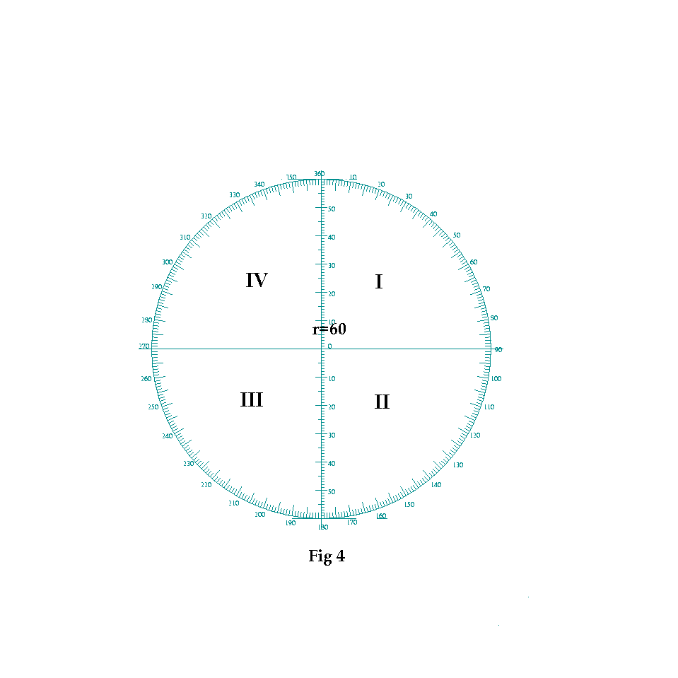

The method:

The following graphics are essential to understand how the method works. In summary they allow to represent the position of a celestial body view from four different positions and how these are interconnected.

Fig 5:

Let’s imagine now that we are standing somewhere at the equator looking towards north. Depending on its declination, a star will move in an imaginary circle as shown below. This apparent movement, as we all know, goes from east to west in a counterclockwise fashion.

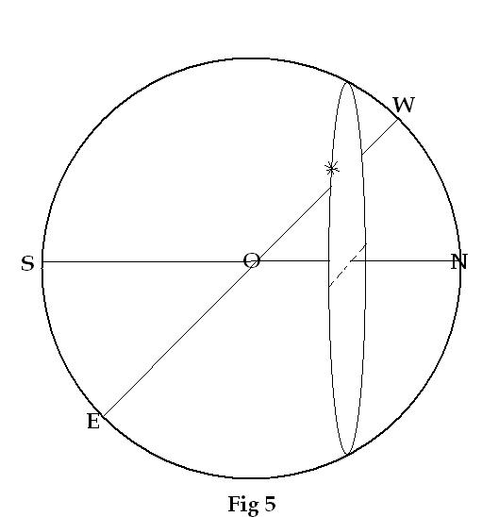

Fig 6:

This star movement is shown as occurring in a circle of radius = r (cos Dec).
The graphic represents a start positioned at a LHA of 310*. The lines for north and south declinations are represented, as well as the horizon by the S/W-N/E line.
The dual representation of the cardinal point indicates that this graphic represents views from the East and South respectively.

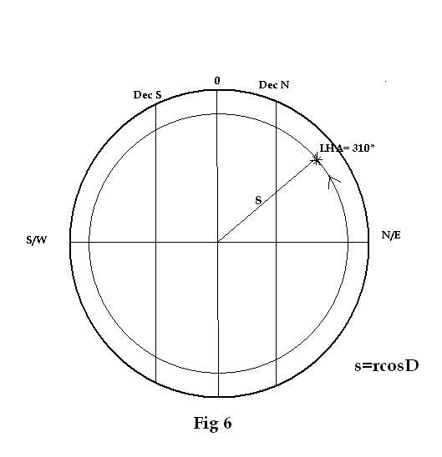

Fig 7:

Dizzy yet? Here comes the best part.
Now we decided to move up north to a Latitude represented by “L” as shown in subsequent graphics.
The overall effect on our perception of the star movement is shown. Now a bigger portion of the star apparent movement will be above the horizon and depending on the Declination, the start may appear to reach our zenith and even move further south.

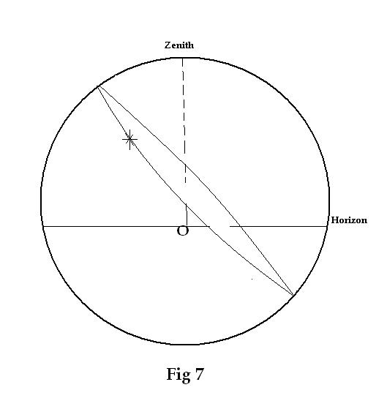

Fig 8:

Now we are going back to our representation as in Fig 6. This time though, the horizon will be lower and the Latitude as an oblique line.
The orbiting circle in relation to the observer is shown in the diagram for a star with Declination 26* N seen from a point at 35* N latitude.

A - B represents the projection of the star movement over the “x” axis, and C – D over the “z” axis.

Please note also the shift of North and South following the change in declination.
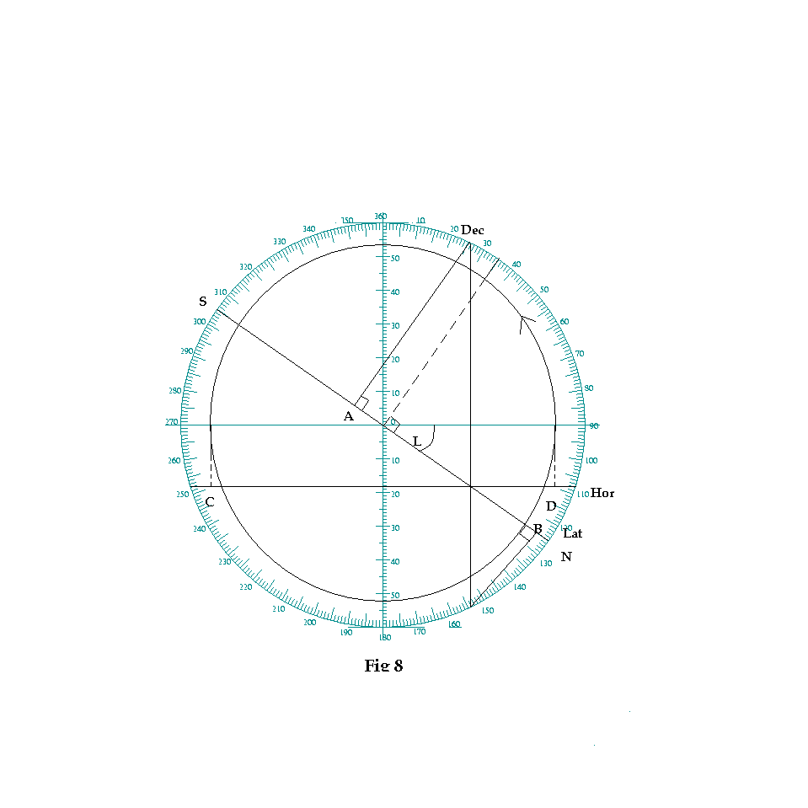

Fig 9:

Similar scenario but now form southern latitude.

Due to the northern declination of this star, most of the apparent movement will occur now below the horizon.

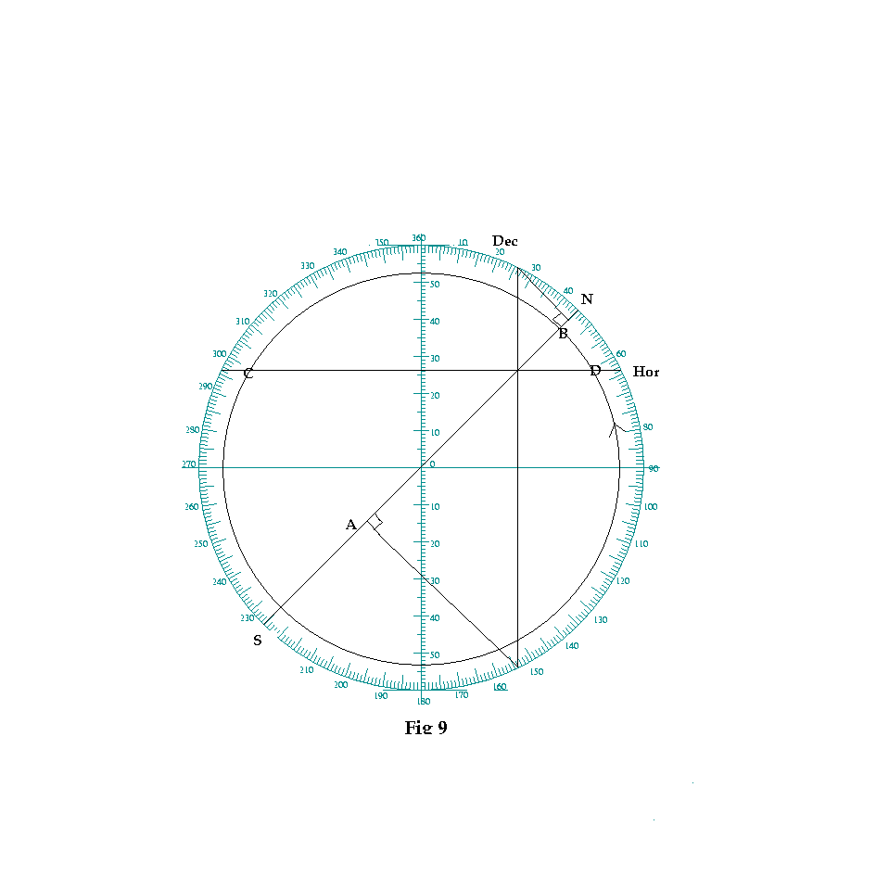

Fig 10:

Here we introduce the first elements of our method, the intersection points “m” and “n”. Their graphic position and their equations are shown.
In the example the graphic for a star with its LHA and northern declination is shown. By now you should be able to tell that the observer is in a northern latitute.
As the graphic indicates, “m” will be positioned and its value be the same also if the star mirrors its prior position.
The value of “n” is independent of the star position.
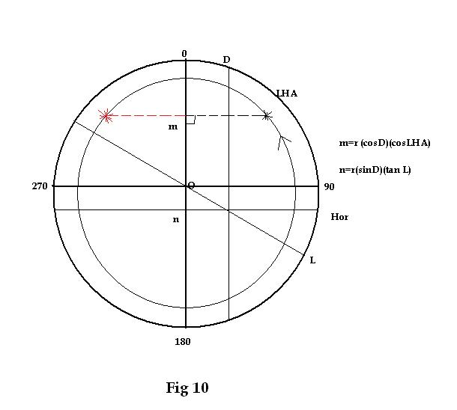

Fig 11:
This is what I consider “the master” diagram and identifies the relation between the three positional axis with the prior defined points “m” and “n” for a celestial body with a Declination of 25 S seen from a 41º N latitude.
The reader is encouraged to find the values of “x”, “y” and “z” using a divider (otherwise would not be a graphic method), the equations as stated above are for confirmation of the values.

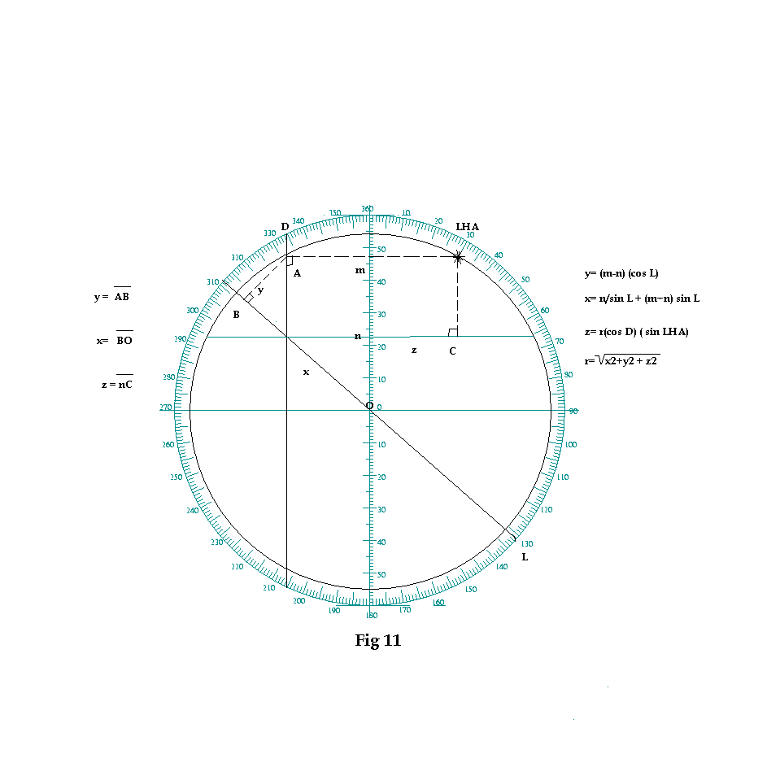
Of note, the sign values of “m” and “n” will differ depending of their values (which one is bigger) and whether they are positioned on the “same”, subtracting from each other, or contrary sides from the 90-270 axis, where they add. In the example above they are in the same side with “m” being bigger in value, hence the “(m-n)” for the equations.

Also the second element in the equation for the value of “x”, will be positive if “x” projects south and negative if north. In this case is projecting south hence the addition. More on this later.

Fig 12:

For those who are not puking yet, here comes the last element of the method.
This represents a view from above (the zenith), of the plane where we are standing (or floating for navigational purposes). The continuous part of the ellipse is the projection while the star is above the horizon. The dotted line thereafter.
The graphic represents the relation between the Azimuth and the axis of “x” and “z” related to the quadrant where the star projects on the plane.
The tricky part is to find the intercept with the ellipse graphically when “Zn” and “Hc” are known but not “LAH”. Trust me, is very painful, do not try it. For this an alternative graphic solution is shown below.
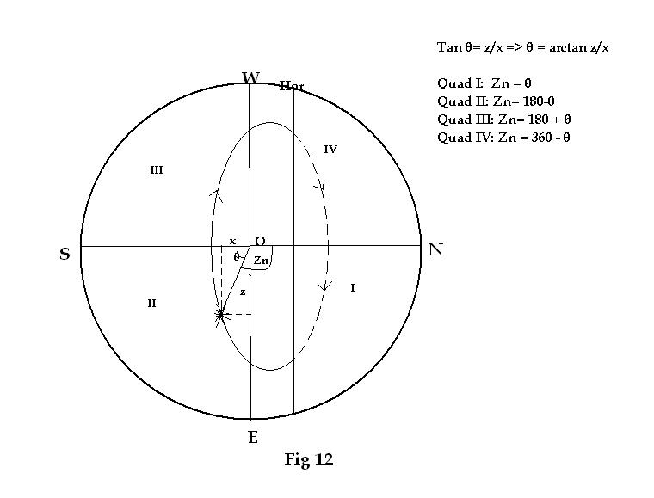

Fig 13:

And now, our calculated altitude as it was defined above, but represented in the middle of the action.

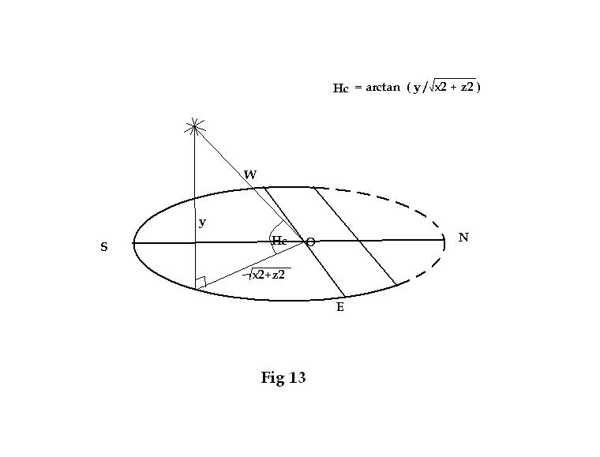

With this I end the introduction of the elements that make this graphic method possible.

Next follows a couple of applications. As a word of caution, this method has not been tested in real navigational situations. The author introduces it as a way to solve and/or compare solutions performed with more conventional systems.

Fig 14:

Let’s assume now that we are placidly navigating and ready to take some morning sights.
Our assumed position is at latitude 35N and a celestial body has a known declination of 26 N with a LHA for the sight time of 310*.

What will be the expected altitude and azimuth in relation to this body?

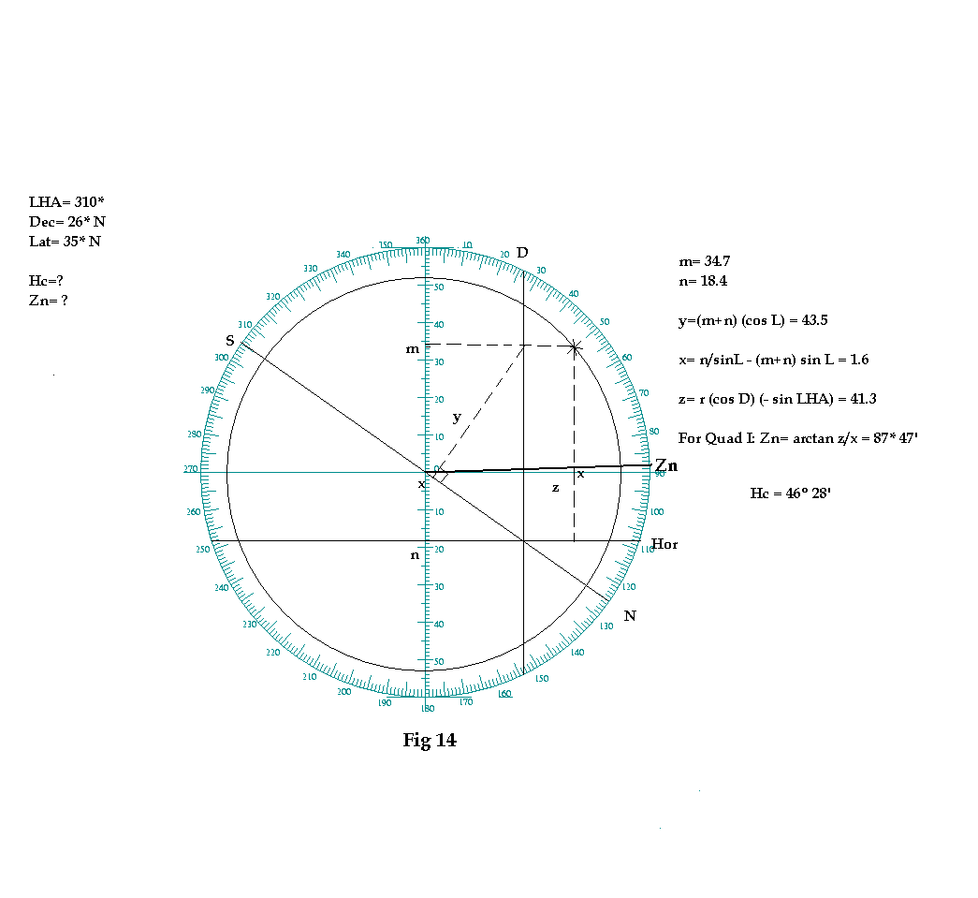
Here the solutions are shown first as equations to understand the next graphic. Once the reader has a grasp of the method may solve it graphically and use the equations for comparison.
First “x”, “y” and “z” values are obtained from the graphic with a divider. From the orientation of “x” and “z”, we determine that Zn is located in Quadrant I and drawn as shown.

Fig 15:

To find Hc, here is the projection that avoids the use of an ellipse as mentioned above.
From the above exercise, Zn is added to the north position for the “x” plane (located at 125* on the rose) and a line OZ is drawn from the center. Then “z” is drawn as an extension of “y” and projected from the “x” plane (line PS).
From the point of intersection “P”, “y” is projected towards the edge of the sphere (point Q). The lines PQ and OQ are drawn and the angle POQ is the Hc.

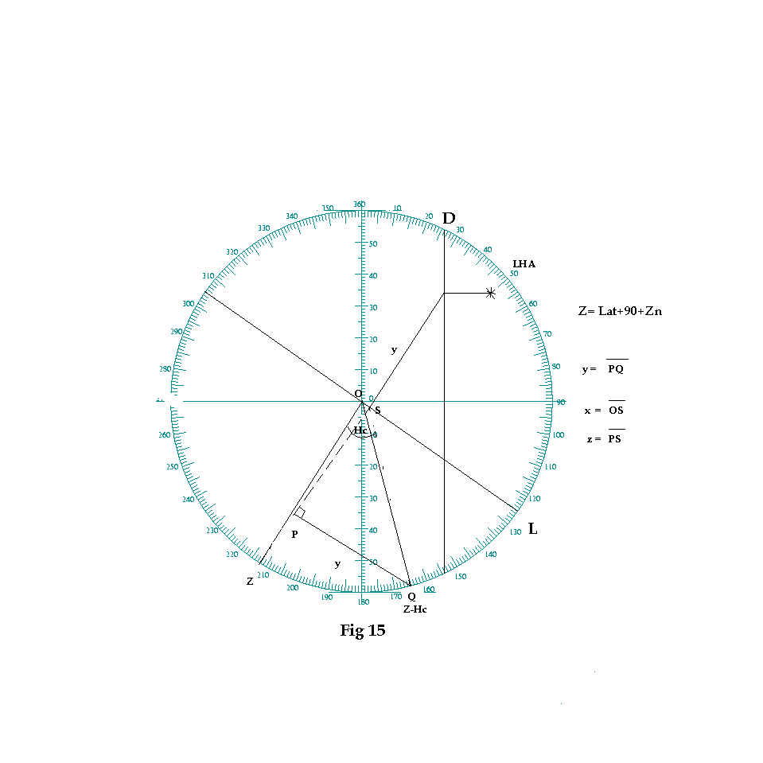

Fig 16:

The next exercise is a much more difficult task, which is to get LHA and Dec of a celestial body graphically from Hc and Zn.
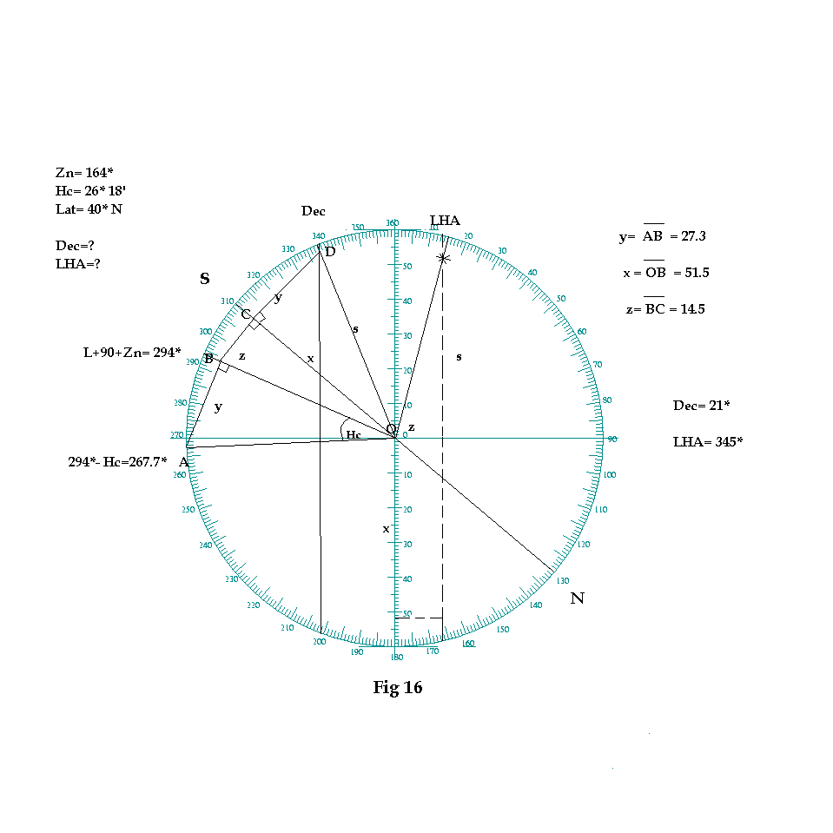
Step 1: From the Latitude line as done before, add the Zn, this gives a value 294*, mark and draw line OB.
Step 2: Subtract Hc from 294*, draw line OA.
Step 3: Project line OA over OB (projection AB). The value of this line should be equal to “y”.
Step 4: Project line OB over the latitude line and draw the projection BC, which should be equal to “z”. By definition, OC becomes “x”.
Step 5: The LHA and Azimuth indicate that the star projection will be on quadrant II (see dotted lines). Hence “x” projects south and from point C, “y” is drawn as shown. The intersection with “r” on point D is where the declination line crosses. Estimated at 21º S.
Step 6: The LHA is then graphically found as shown.

Of note, in every case, the projection of point B (on the triangle ABO), over the “x” plane should always extends or include the line “y” (CD on the graphic).

With this I end this presentation. As mentioned before, this method was born as an accessory to more accurate methods to correlate LHA and Hc-Zn without need to use tables or star finders. The real strength of this method stands on the proper combined use of the graphic and equations.

Of course, for navigational purposes, knowing the position of Aries is required when working with stars, and for that the use of tables will be needed since a watch giving that information does not exist to my knowledge (wouldn’t that be wonderful?)

Your comments, questions, critics will be appreciated.

You may contact me at torinese1@hotmail.com.

Fair winds.

Marco Costa

