˚ Mark 2 Navigator’s slide rule comparison tests.
I have just completed a copy of Bob Goethe’s very interesting Mark 2 slide rule which only took a couple of hours to build by the following simple technique:
- High resolution copy of Bob’s scales PDF loaded into my old Photoshop elements
- Resize to exact same scale dimensions as my trusty 1960s school Thornton
- High quality photo print on ordinary domestic ink jet printer. Cut strips accurately with scalpel and steel rule straight edge.
- Carefully stick the scale strips to the empty reverse side of the Thornton, lining up exactly with the Thornton scales.
- Add acetate strip with fine line and stick to reverse side of the curser. All done! Works perfectly.

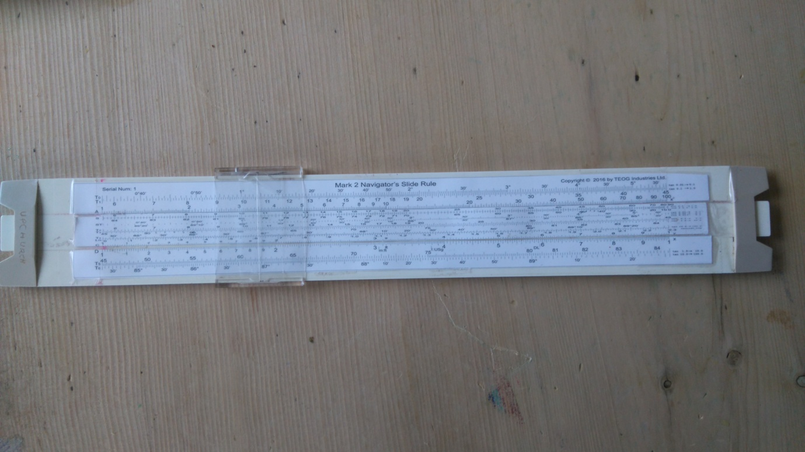
Empty and un-employed reverse side for over 50 years, now brought to life courtesy Bob Goethe.
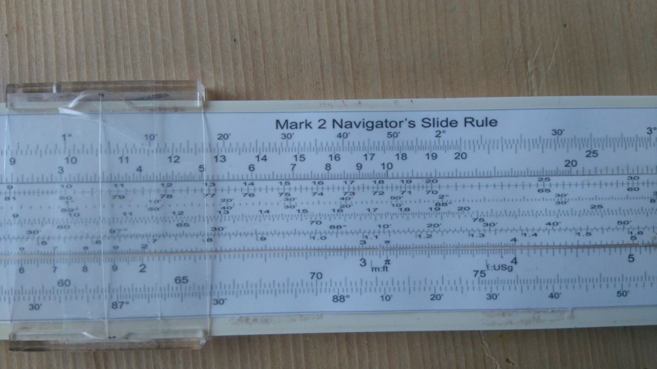
Original School boy Thornton circa 1963,
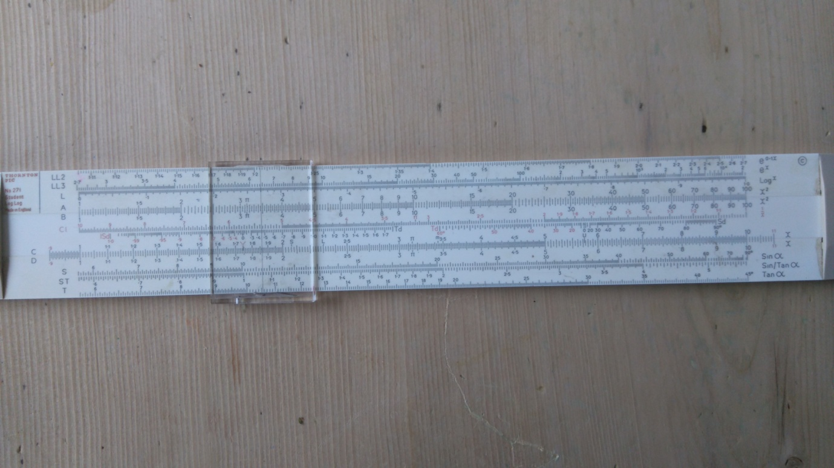

Test drive and comparison with Bygrave Replica, Fuller 3 and Brown-Nassau.
Advantages
Bob’s Mk2 has a number of very useful features not found on other conventional slide rules.
- Multiple identical sine, cosine, tangent scales, enabling direct multiplication and division of trig angles. Bygrave does this and my new Fuller 3(AHA) , (but for Fuller 3 ,only tan <45˚ I need to correct this. ). This mk2 has tans to 90˚. You do need this for Bygrave type calculations (see below).
- Sines and cosines, albeit less extended scales and therefore less accurate than the tan scales.
- Can therefore use this for Bygrave type formulae
- The simple linear scale layout enables very easy, direct visualisation of what is going on. Very good therefore for working up formulae visually.
- The linear format allows multiple scales in parallel, much more difficult with cylindrical rules.
Disadvantages
The main disadvantage is the limited accuracy with the limited length of the scales. The 50 ft scale length on my Fuller 3 allows 4-7 decimal places, required for LOPs and Lunars.(same as calculator) The Bygrave replica has scales over 25 ft and gives accuracy to 2’ of arc.
Also, I find cylindrical rules easier to build due to the easy, cheap availability of precision plastic tubes. My mk2 copy relies on the Thornton structure. All I had to do is stick the correct scales to the empty side .Building a precision linear structure would be a lot more difficult.
Test drive comparisons
In honour of Bob, I used the Great circle example from his manual page 50+ .this is the same formula as for LOP, except H is the difference in Longitude, LAT= departure lat, and DEC is the destination lat.
H=39˚ 03’, Lat = 50˚ 43’, destination LAT=D=53˚ 53’
Moves
These are described in Bob’s manual. I used an adaptation of Gary’s Bygrave form. I think it took about 9 moves and about 4 minutes, but I had never used this slide rule before. I got exactly the same result as Bob, i.e W=60˚30’, Az=66˚53’ and Hc=66˚17’
Bygrave replica
Similar number of moves, but I’ve used this hundreds of times, so only took about 2 minutes.
Results
W=60˚27’, Az 67˚ 05’, Hc=66˚ 13’.
These are exactly the same as per calculator.
Fuller3 (AHA)
My current tan scale only covers up 45˚, so I have to use cot W=cos H x cot Dec.
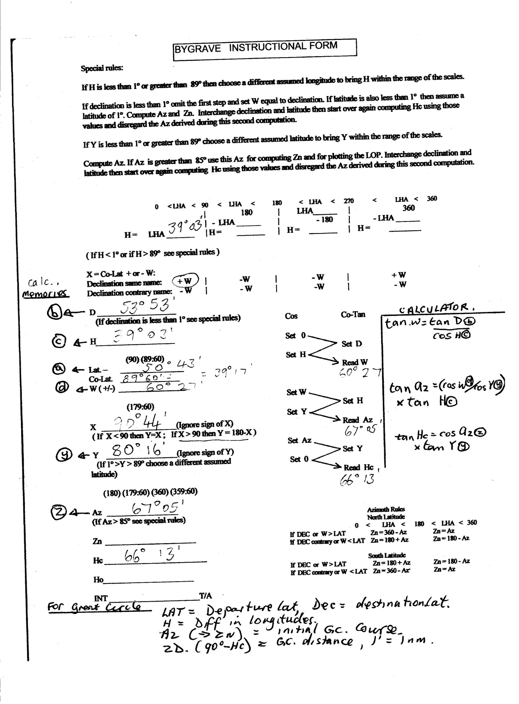
D>tan 3 (90˚-53˚53’=36˚7’), A>1, C>cos 39˚3’, (0.7766 at F)>B, read 29˚33’ at D
89˚60’- 29˚ 33’ =60˚ 27’
For the AZ, I used tan Az= (cos W/cos Y) x tan H.
C>cos 80˚16’, A>1, C>cos 60˚ 27’ (read 2.9171 at A)>F, A>1, D>39˚3’ (read o.8112 at F)> B, read 13˚ 13’

This gave me an incorrect AZ of 13˚19’.( tan=0.2366) I assume, at sea I would know the rough AZ from the compass bearing, but assuming it was >45˚, I took the reciprocal 1/2366= 4226. Tan⁻¹ =22˚54’44”. Subtract from 89˚60’ = 67˚ 5’.
This is not always obvious, so you really do need a tan scale covering <90˚ to do Bygrave formulae easily.
Tan Hc =cos AZ x tan Y. Y > 45, therefore use cos AZ/ tan(89˚60’-80˚16’= 9˚44’)
D>tan 9˚44’, A>1, C> cos 67˚ 5’, read 22706 at A, but need cot Hc, so use reciprocal, 1/22706.
1>F, A>22706, A>1 read 4407 at F,.= 23˚47’, (notice, no need to estimate position of decimal point.)
89˚60’ -23˚ 47’ =66˚ 13’= Hc.
The Fuller therefore gave identical answers to the Bygrave and calculator, but took a lot longer because of the corrections for tan values >45˚.
Brown- Nassau
This is really a graphic slide rule and uses a variation of the cosine formulae, not Bygrave.
This used only 4 simple moves, no need to calculate colat, X or Y, and took about 1.5 minutes.
I got Hc 66˚ 10’ , Az 67˚
In the past, I average accuracy to about +/-5’, with occasional 10’.
Conclusions
Bob’s Mark 2 is as quick as the Bygrave, but not as accurate, which for Hc for LOPs is probably more important than for great circle. The simple linear layout is very good for experimenting with different formulae.
The Fuller 3 takes more moves and longer time, but has the same accuracy as the Bygrave and calculator. It would be improved by the addition of tan scale >45˚ <90˚, but there is no room on the already crowded cylinders, so this will have to go on the current tan scale, probably using red or green numbers.
The Brown-Nassau is the easiest and quickest with similar accuracy to the 10’ slide rule.
The Bygrave Replica is still my favourite LOP/great circle slide rule for speed, and accuracy. I use the Fuller mostly for Lunars.( the Thompson abbreviated formulae which are easy and quick and surprisingly accurate.)

