idday Sun mer pass and Moon sight to cross – 2024

Scenario :
Actual position (AP) for entry in the app :
19º 50’.30” S, 26º 17’.12” W. (19º 50’.5 S, 26º 17’.2 W).
Date : Monday 12th Feb 2024

DR Position for use in the sight reduction process :
19º 09’.0 S, 26º 29’.0 W.

The aim is to obtain your latitude from a midday Sun mer pass. You can use the Planet Location Diagram to see if another heavenly body is available for a second sight at the same time to cross the latitude and give you a position.

The Planet Location Diagram is year specific so you need the 2024 version.
Draw a line across the diagram on the 12th Feb.
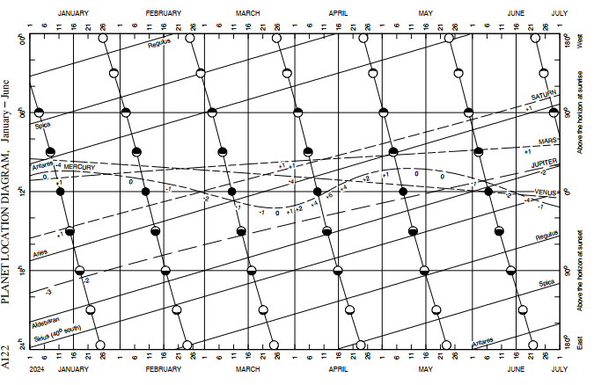

The central 12h horizontal line represents the sun’s mer pass and is the chart’s reference line. Where the moon line crosses the blue 12th Feb line, there is a crescent moon that has its mer pass around 3 hours after the sun’s. You don’t need its mer pass but the diagram tells you that the moon follows the sun and will be visible around midday when you are shooting the sun. The same applies to Jupiter around 5 hours behind but will probably be too low in the sky for a good sight.

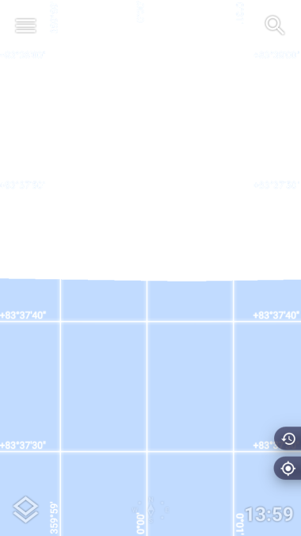
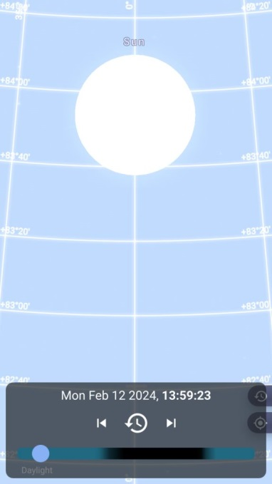
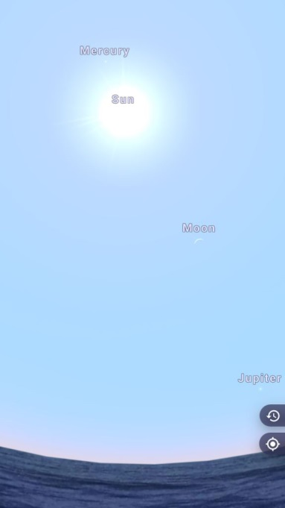
Keep zooming in.
Take the sight as :
Hs = 83⁰ 37’43”
ie 83º 37’.7
Using the proformas, you firstly need to sort out the sun’s mer pass time.

MER PASS - SUN | Day Date / Month |  | Notes and calculations
Date | Monday 12th Feb 2024
DR Pos^{n} Lat | 19º 09’.0 S
Long | 026º29’.0 W
 | hr : m : s
Mer Pass UT @ Gr | 12:14:00
DR Long +W cor^{n} | 1:46:00 |  | From Conv^{n} of Arc to Time table
Mer Pass UT @ DR | 14:00:00 |  | Target Mer Pass time
Confirm date | Same
 | SUN
Sight time | 13:59:23 | Actual sight time | Time of maximum observed altitude.
Hs | 83º 37’.7 | LL
IE | 0
Dip | 0
Ha | 83º 37’.7
Corr^{n} | +16’.1
Ho | 83º 53’.8 | LL
Dec^{n} (Sun) 13 hr : S | 13º 45’.1 | Enter d value
d +/- +0.8 Corr^{n} | + 0’.8 |  | 90º 00’.0
Dec^{n} (Sun) : S | 13º 45’.9 |  | Ho - 83º 53’.8
ZD | 6º 06’.2 |  | ZD 6º 06’.2
Latitude | 19º 52’.1 | S | Latitude = Dec + ZD
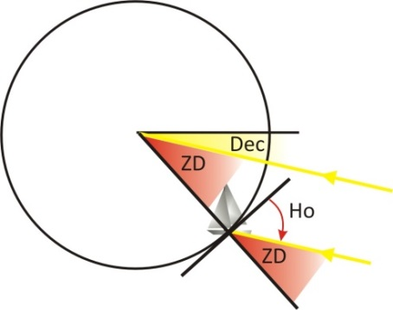
Compare to the AP latitude of 19º 50’.5 S. This is close enough to show your workings are correct.

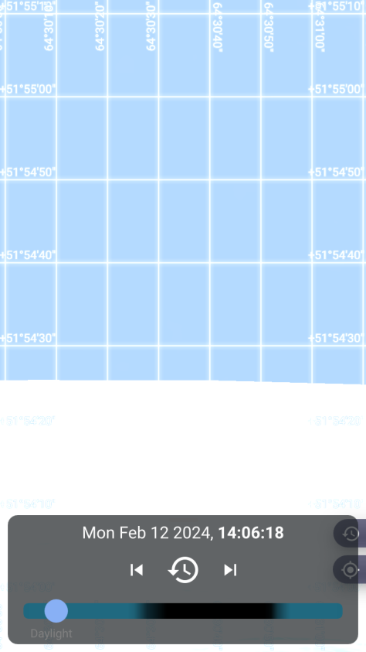
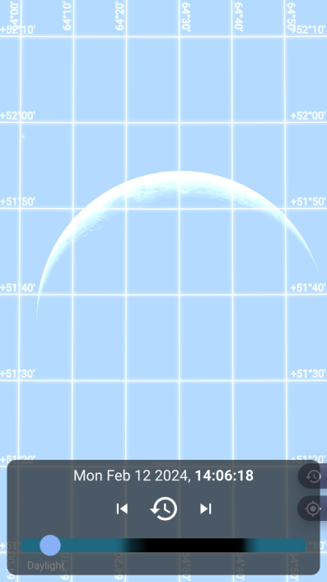
You can now find and shoot the moon’s upper limb to give you a crossing position line. It is not brilliant but as it is available it will give you a reasonable position instead of just the latitude.
Assume you take the sight a few minutes later at 14:06:18 UT@DR.

After zooming in you can read off 51º 54’ 25”, ie 51º 54’.4.

MOON SIGHT | Day Date / Month / Year |  | Notes and calculations
Date | Monday 12th Feb 2024
DR Pos^{n} Lat | 19º 09’.0 S
Long | 026º29’.0 W
 | hr: m : s
Sight time | 14:06:18 | UT @ DR
 | MOON
Hs | 51º 54’.4 | UL | Look up GHA, Dec^{N}, V, d & HP
IE | 0 |  | at this point, need HP to get
Dip | 0 |  | Ho.
Ha | 51º 54’.4 |  | 14Hr GHA 351º 13’.1, S 1º 12’.0,
First Corr^{n} + | 45’.5 |  | V= +10.6, d= +17.7, HP 60.7
*HP 60.7 Corr^{n} + | 4’.6 | UL
 | -0^{O} 30’.0 | applies UL ONLY | 51º 54’.4
Ho | 52º14’.5 |  | 45’.5
GHA 14 hr | 351º 13’.1 | *Ent V, Dec^{n}, HP, d | 4’.6
06 m 18 s | 1º 30’.2 |  | 52º 44’.5
*V +/- +10.6 Corr^{n} | + 1’.1 |  | - 30’.0
GHA Moon | 352º 44’.4 |  | 52º14’.5
CP Long -W | 26º 44’.4 | W
LHA Moon | 326º | (whole number)
*Dec^{n} 14 hr S | 1º 12’.0
*d+/- +17.7 Corr^{n} | + 1’.9 | Inc & Corr 6 mins
Dec^{n} Moon S | 1º 13’.9 | Same / Contrary
CP Lat | 19º S | N/S (whole number) | From Vol 2 : 52 08 +30 114
Hc | 52º 08’.0 | *Enter d & Z
*d+/- +30 Corr^{n} | + 10’.0 | Table 5 | Column ‘d’, row ‘Dec^{n} minutes’
Hc | 52º 18’.0
*Z | 114º |  | LHA > 180, southern hemi.
Zn | 66º |  | Zn = 180 - Z
Intercept | 3.5nm | Away (Hc > Ho)
 |  | Towards (Hc < Ho)
Bearing Zn | 66º

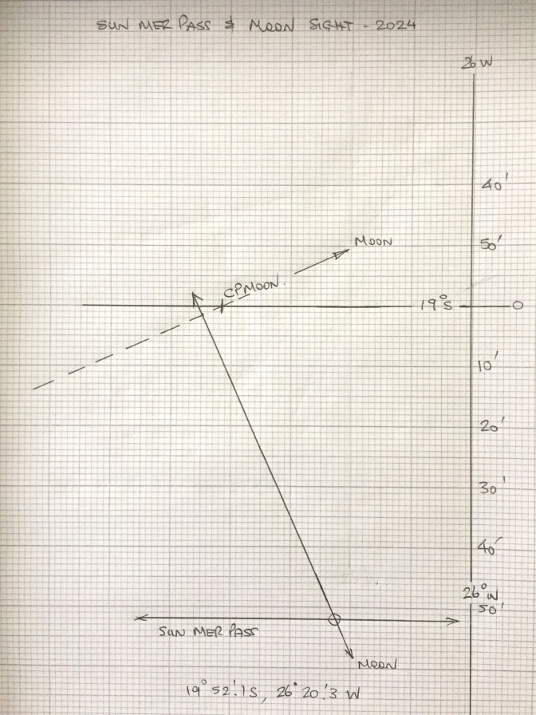
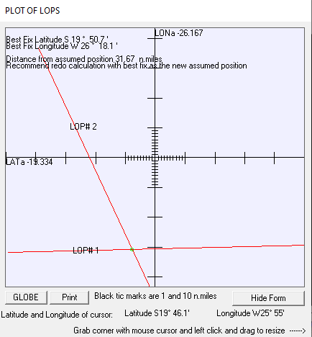
The fix at 14:06 UT@DR was :
19º 52’.1S, 26º 20’.3W.
TeacupNav came out with 19º 50’.7S, 26º 18’.1 W.
These compared to the AP of 19º 50’.5S, 26º 17’.2W.

