Improved Accuracy of the Brown-Nassau Graphical Slide Rule by using whole number Latitude and LHA assumed position.
Each black dot on the base plate represents a particular value for latitude on the Y axis and LHA on the X axis. They are spaced out to the nearest whole degree.
Likewise the blue lines on the rotors are spaced at one whole degree.
Declinations are spread along the expanded outer circumference of the rotors and can be read or set to 2’ accuracy with the aid of the Vernier scales.
The original instructions for use described by Luylx recommends placing a pencil/pen dot on the base plate to locate the DR lat and LHA. After the rotor in turned to fix the Declination (accurate to 2’), the resulting Hc is found by interpolating the position of the pencil dot among the blue lines, which are spaced at 1 whole degree intervals. With good “eyeball” practice, I have managed an average of 5’ accuracy, but with the occasional outlier of 10’. This method of placing the pencil mark and then interpolating the final position is clearly a major potential source of error.
I recently tried the obvious and simple expedient of using whole number APs, thus:
- Place your red dot AP based on DR or whatever.
- Rotate rotor to the (accurate to 2’) declination. Lock rotor using my ”high tech “ painters masking tape lock.
- Do not try to interpolate the position of the red dot. Instead, find a nearby printed black dot that sits perfectly on a blue line. (confirm with magnifying glass) Choose a dot ≤ 1˚ away, otherwise you may introduce additional errors due to the overly long intercept plot on the chart.
- This black dot is your new AP, very accurate, but to the nearest whole degree.
- The blue line gives the accurate Hc, again to the nearest whole degree.
- If no suitable, nearby dot sits exactly on a suitable blue line, choose the best and interpolate the exactly accurate dot’s position close to the exactly accurate blue line. This interpolation is a lot easier and more accurate than one obtained from hand pencilled dots where you may have the compound errors resulting from the initial pencil hand plot and the subsequent “eyeball” interpolation.
I suppose this is analogous to the use of whole number APs for reduction tables.
Results so far.
I tested this against calculator and Bygrave for 10 LOP reductions.
8 were within ≤2’ compared to calculator, 1 was 3’ out and 1 was 5’ out. The last one gave the same result after several repeats, so I assume it is the result of some unseen “index error” in the slide rule, hopefully only affecting one area of the curves. I will investigate this in time.
Conclusions
Using whole number APs on the BN eliminates the major source of avoidable error and brings the accuracy up to the same level as the Bygrave slide rule. The advantages are that it is much quicker than the Bygrave and requires no writing down or calculation of intermediate values W , X and Y or colatitudes. The single pencil mark only needs to be approximate to help find the nearest very accurate intersection of whole number AP dot and Hc curve.
Despite my enthusiasm for the Bygrave, I now prefer the BN for routine LOPs and wonder what Chichester would have thought if he had had one in 1930?
Francis Upchurch

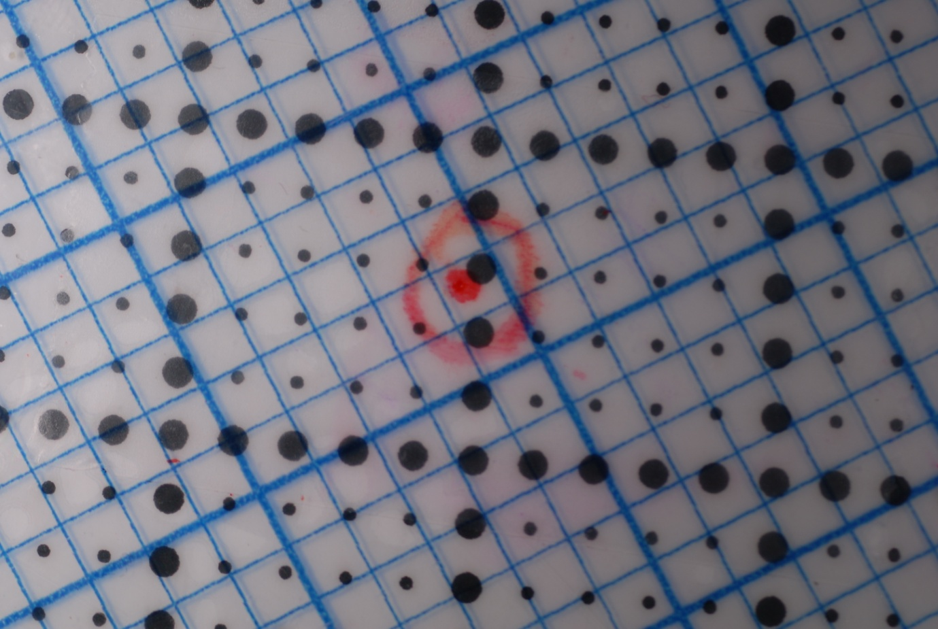
The red dot was placed by hand lat 22˚49’, LHA 75˚20’. The risk of interpolation errors is obvious. The printed black dot at 10 o’clock is at lat 23˚. LHA 76˚ whole numbers, exactly. It sits on blue line 24˚ for Hc. Calculator gives 24˚2’.
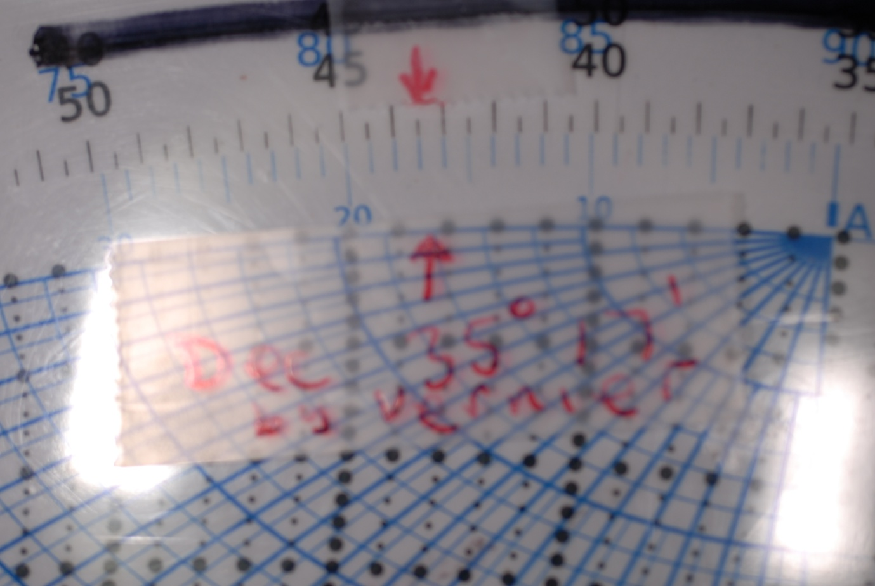
The declinations scale plus Vernier allows reading and setting to within 2’.

