Brown-Nassau Spherical Computer. Replica building instructions.

Introduction
The Brown-Nassau Spherical computer was developed for the aviators in the US Navy in 1944 by Brown and Nassau of the Case Institute, Cleveland. It is an ingenious graphical circular slide rule with curves and dots representing constant latitude, declination and LHA. Starting with known latitude, LHA and declination, the Hc and Az can be found with a few simple movements of the rotating quadrants in about a minute, to an accuracy of 5-10’.
I rediscovered this device by chance from two original papers by Brown and Nassau (
A Navigation ComputerAuthor(s): O. E. Brown and J. J. Nassau Source: The American Mathematical Monthly, Vol. 54, No. 8 (Oct., 1947), pp. 453-458Published by: Mathematical Association of America Stable URL: http://www.jstor.org/stable/2305703 .) and JM Luykx (https://www.starpath.com/foundation/NN-vol-3.pdf).
Greg Rudzinski, I think, found details of the only known surviving example in the Smithsonian Air and Space Museum:
Plotter, Navigation, Celestial, Brown-Nassau Type National Air and Space Museum.

Harri Ojanen very kindly produced accurate, computer generated graphs, derived from the equations described in the Brown-Nassau 1947 paper. I then took up the relatively simple task of building a working replica. Use version 3 which has blue coloured quadrant scales.
We only have photographs and design details of the AX side and therefore guessed at the structure of the other, BY side. However, it works and is likely to be correct.
Simple small scale, “drawing pin” pivot bearing prototype
This is easy to build in less than 2 hours and requires no engineering skills or equipment. It cost virtually nothing.
- Plywood rectangle 30x30cm , 0.5cm thick
- Print 2 copies of base plate dot graphs on white photo paper.
- Print line 1 (BY) and line 2 (AX) on transparency film.
- Check that the graphs overlap exactly. If not, possibly due to the printer. If they do not overlap exactly, do not proceed, since even a fraction of a mm out will result in unacceptable errors of Hc.
- Enclose the printed graphs in transparent laminate.
- Stick white dots scale to both sides of the board.
- Cut the curve of the quadrants
- Very carefully line up the pivot point. This has to be exact. The slightest fraction of an mm error will result in unusable inaccuracy.
- Very carefully push a drawing pin through the pivot point. This has to be exact, but I found it easy to do first time in under a minute.
- Use black permanent marker pen to blot out the unwanted Vernia scales as follows:
Y Vernia, black out upper 0-15, B Vernia, black out lower 0-15
A Vernia, black out upper 75-90
X Vernia, black out lower 75-90

- Add instructions and Index of Vernia Tables for AX/BY.
- Try it out as per the instructions.
Brown-Nassau Instructions
- Select correct side and Vernia
- Pencil mark Lat and LHA on correct baseplate
- Set Dec on correct Vernia
- Read Hc from 2 mark position among alt curves on rotor.
- Select side for Az
- Set Hc on correct Vernia
- Dec point rotor/lat point baseplate, extend down to Az bottom baseplate.
I have found a red marker pen (erasable) works well on the plastic laminate surface.
If you use an AP with full integer LAT and LHA, you simply circle the appropriate printed dot on the base plate.(more accurate than placing ink dots for degrees and minutes) The Vernia increases the accuracy of the declination setting.
I find the human eye can judge the position of a dot between 2 lines rather accurately. I have generally found Hc in under a minute to 5-10’ accuracy.
Full sized version using transparent polycarbonate sheet off cuts and brass post screw pivot bearings.
This is closer to the original design and the increased size should result in greater accuracy. Polycarbonate sheet is very robust, easy to drill and cut and the device could double as a weapon to repel boarders! However, a health warning! It took me 3 days to make, 90% of the time doing multiple trial and error attempts at achieving accurate 5mm drilled holes for the brass, post screw pivot bearing. If you cannot accurately drill a 5mm hole to within a fraction of a mm, then do not attempt this. I used a Dremel (hobbyist) drill bench. The ideal would be a professional drill and engineer skills. This version still cost virtually nothing, using scrap off cuts.
- Cut polycarbonate base plate 30x 35cm
- Cut polycarbonate quadrants x2 , 28cm on X and Y axis, use compass to outline the curve. Use accurate jig saw to cut the curves.
- Clamp quadrant to appropriate position on base plate.
- Use bench drill to drill accurate 5mm hole through both quadrant and base plate.
- Repeat on the other side of the base plate, taking care not to drill hole close to opposite side area for graphs.
- Print Dots graphs x 2 for both sides, A/X and B/Y. My A4 printer allows poster (2 sheets of A4) printing at 220% enlargement, with accurate alignment marks. I used a scalpel and steel rule to accurately cut along the marks to allow a perfect join to create the full graph roughly 24x24cm. If you cannot manage this, I suggest using a professional A3 printer for the job.
- Check alignment of the overlapping graphs as above. (they must line up perfectly)
- Laminate as above.
- Stick white dots base plate graphs on both sides.
- Carefully line up blue quadrant graphs on top of dot base plate graph.
- Use compass to draw” fiducial” (as Hanno terms it) rings to help centre the hole.
- Accurately drill 5mm hole through clamped graphs. They must be perfectly centred.
- Install brass post screw bearing (5mm diameter rod)
- Tighten as required to achieve correct degree of resistance.
- Black out Vernias as above.
I have found mean accuracy of 2-5’, so nearly as good as the Bygrave, but much quicker and easier.
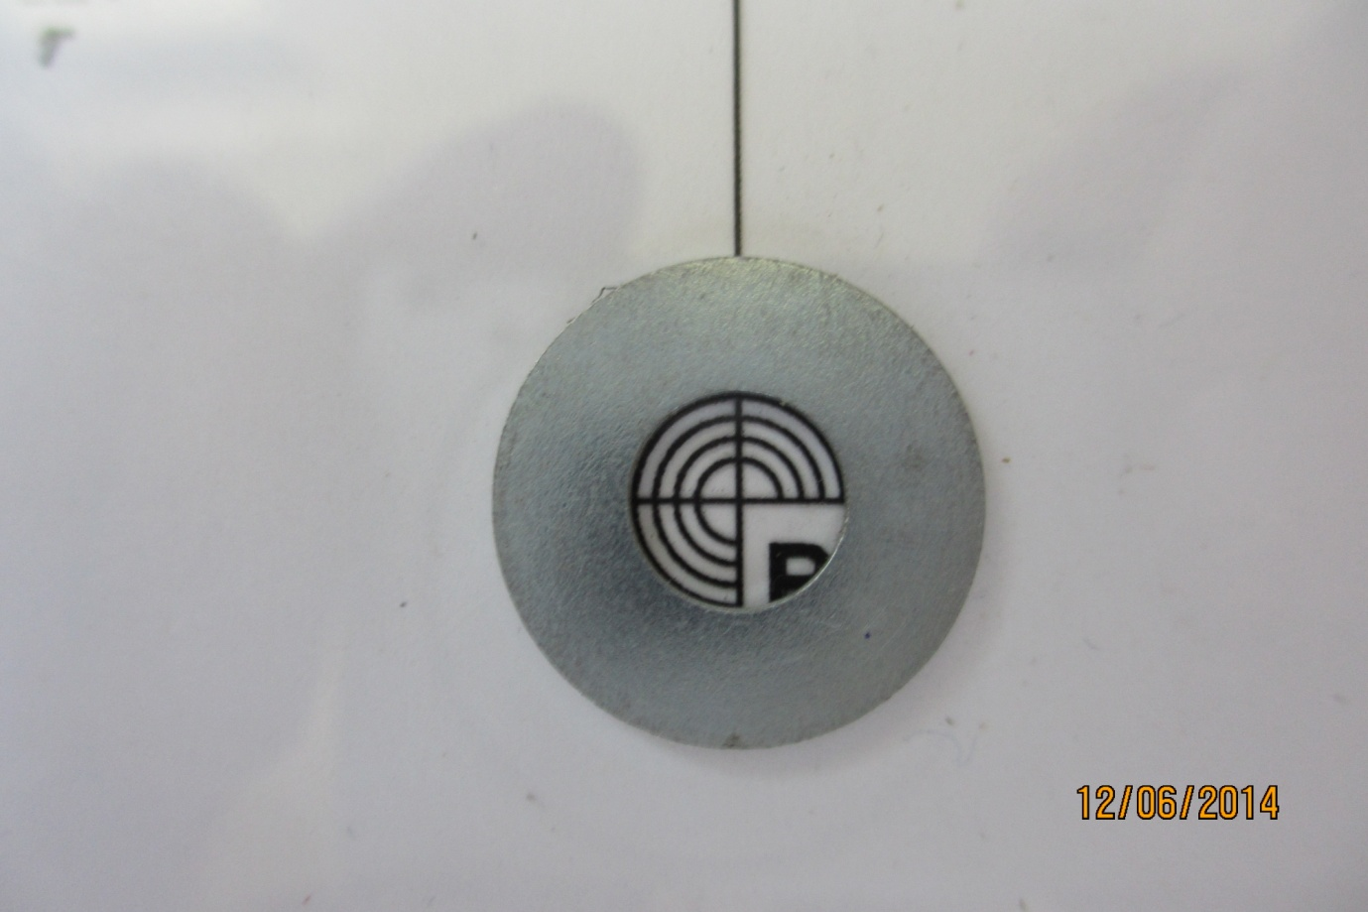
Fudicial marks for accurate centre (Hanno Ix)

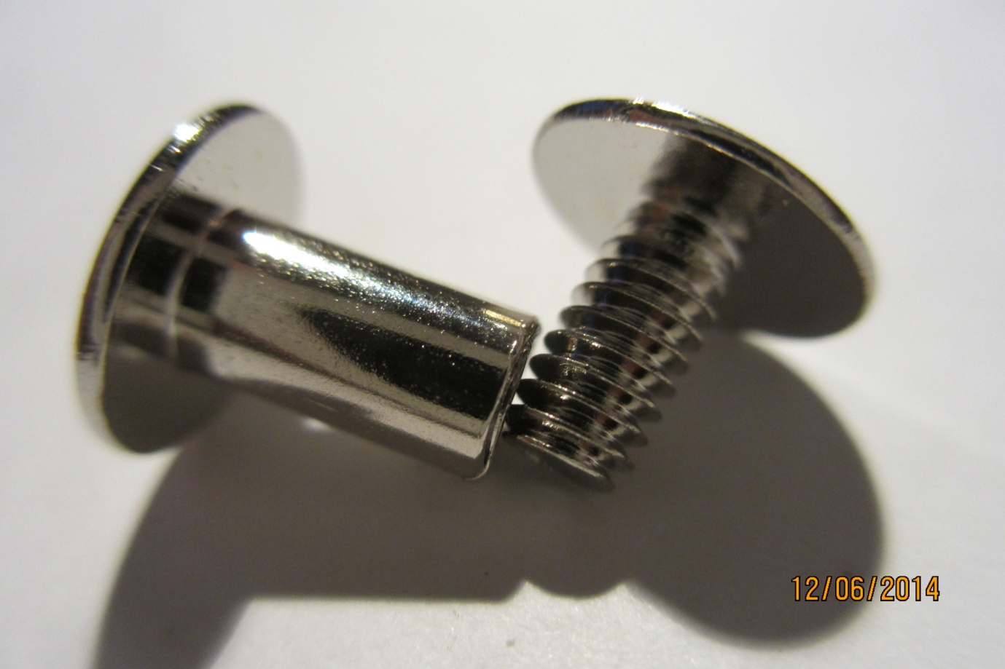

Post screw bearing (5mm diameter shaft)

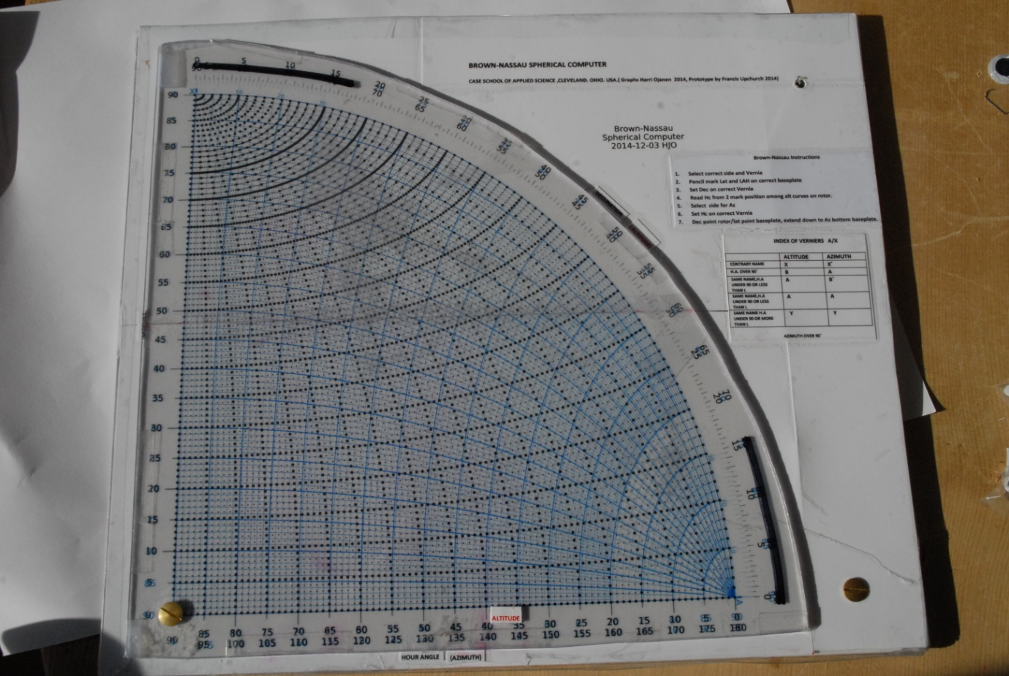
Full size version Side A/X

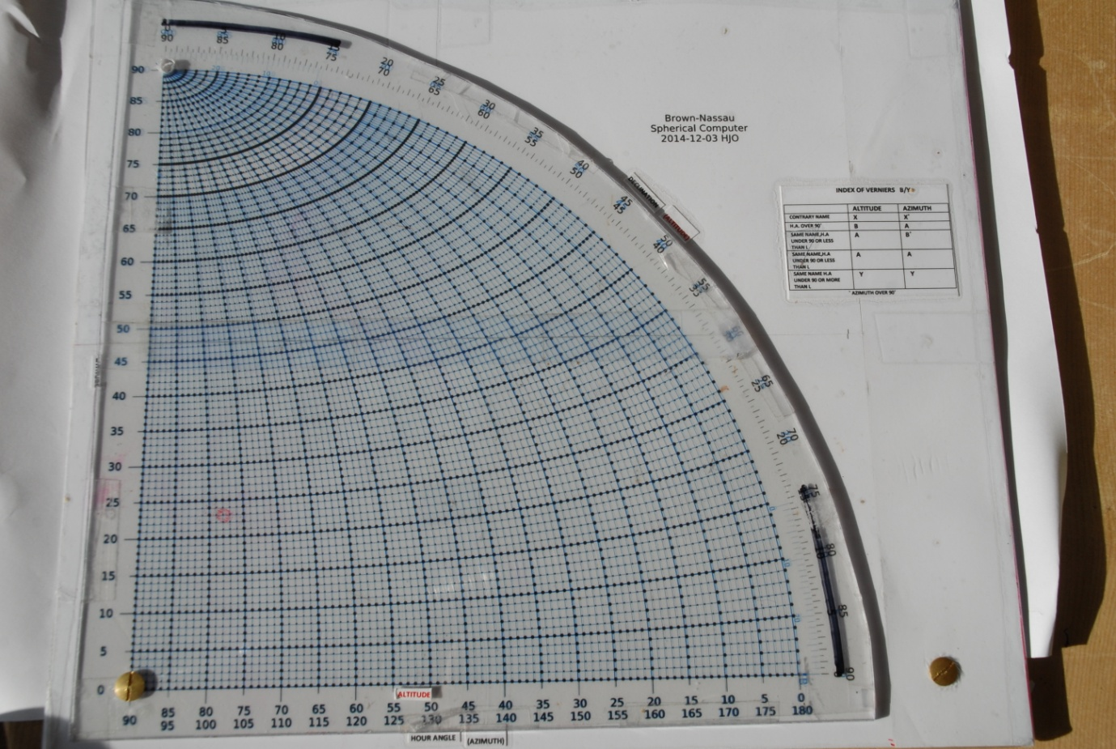
Side B/Y
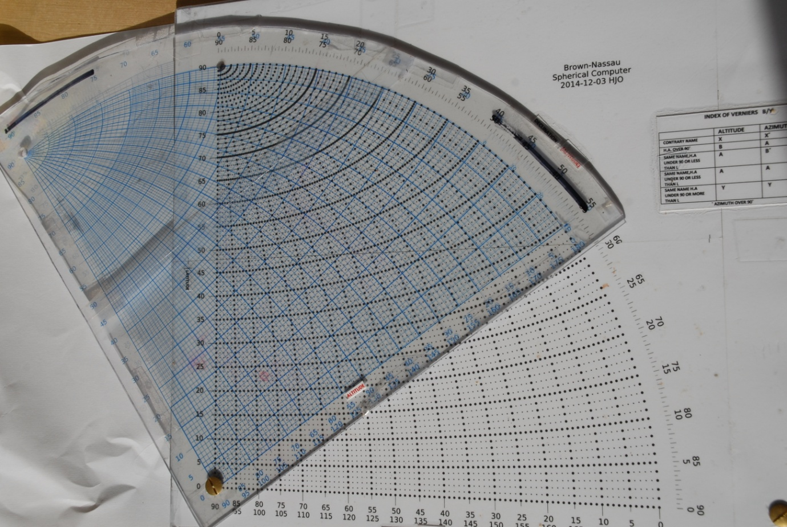

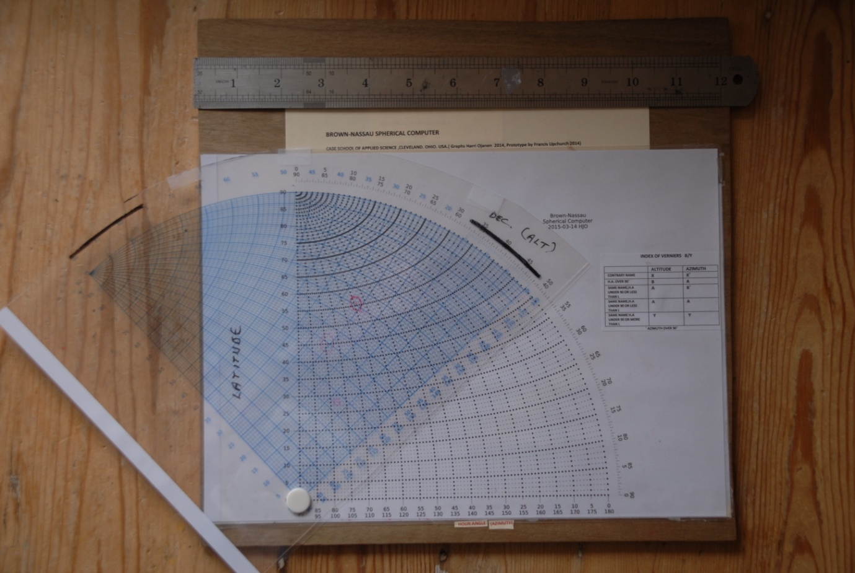
Simple small scale using drawing pin pivot bearing

