Building a Bygrave cylindrical slide rule. Francis Upchurch 11/11/13
Introduction
Celestial navigation is one of my main hobbies and I particularly enjoy a non electronic approach using a sextant to measure various angles of the heavenly bodies, which , with a little bit of maths and accurate time from a mechanical watch, can miraculously fix my position to within a mile or two (or five). Free apps on my phone can do the maths quickly and perfectly, but I also enjoy the non electronic, organic feel and interaction of the slide rule. Obsolete, but fun, just like the sextant. For similar lost (and found?) souls, here is a brief description of how I built a couple of accurate replica slide rules at minimal cost.
Bygrave Cylindrical slide rule.(AML Position Line Rule)
I have no specialist knowledge, very little maths and just like slide rules as I like sextants. My 1960s Thornton school- boy linear rule has a 10 inch scale. It is not accurate enough ( 2-3 decimal places) for navigation. Cylindrical slide rules like the Bygrave have long spiral scales up to 8 meters( 24 feet) long, capable of providing accuracy to 1-2’. (A detailed description is provided by Ronald W M van Riet 2008). Gary LaPook and others have also described this in detail in Navlist archives.
The AML position line rule was invented by Capt Bygrave, RAF in the early 1920s and produced in small numbers by the Air Ministry Laboratory. It was specifically designed to calculate the navigation triangle and not as a general use slide rule. Francis Chichester famously used one during his solo flight across the Tasman Sea in 1931. He had to find a tiny island after several hours of flight. With no electronic aids, he took multiple sextant shots of the sun and worked the maths with his Bygrave, preferring this to the theoretically more accurate, but in practice, time consuming, laborious and error prone log table method. (The Air Almanac short tables became available a few years later, in time for the war.)
I was lucky to find a relatively cheap, rare and perfect original on ebay in 2009. This works perfectly, but is far too precious for the wet, pitching and rolling place that is my small boat at sea. I therefore made a prototype copy, with help and scales from Gary LaPook, Zvi Doron and others on Navlist. This works perfectly. I then produced my Bygrave replica in 2010, courtesy the wonderful authentic, computer generated scales from Wayne Harrison. (see his slide rule Google site and nwharrison@sympatico.ca)
They are all equally accurate. So it is just the “look and feel” I was after. (My slide rule thing is largely emotional and not logical.)

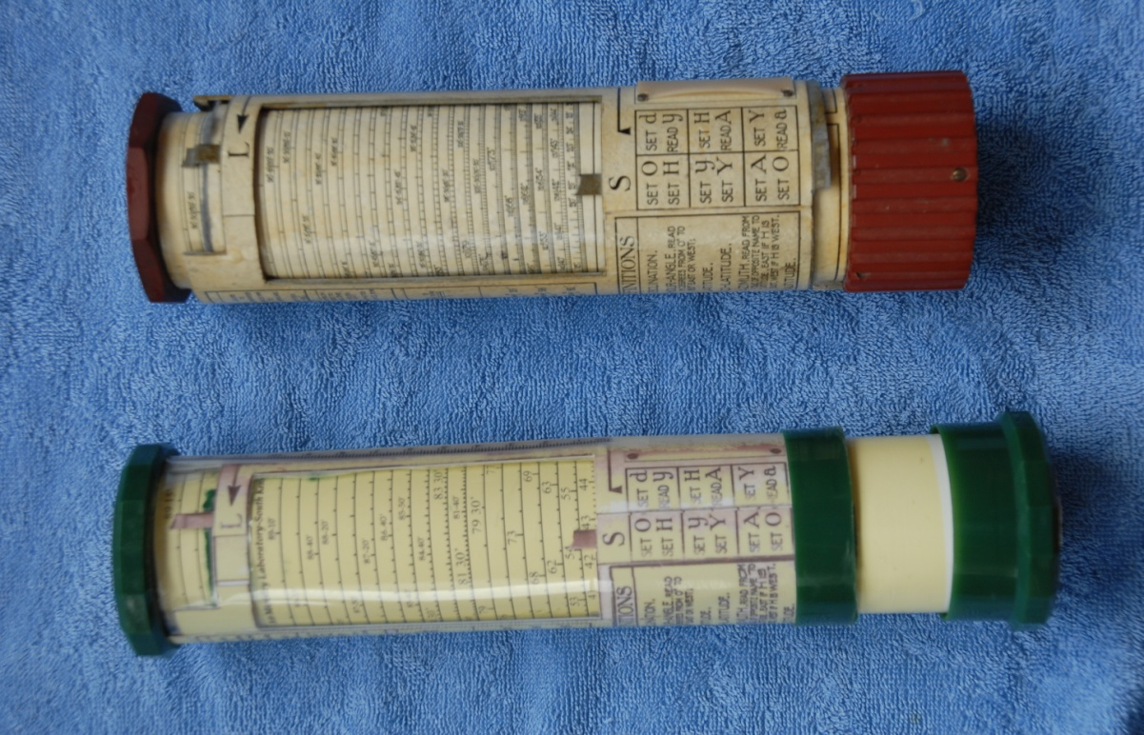
Original Bygrave 11A above first copy (Scales from Gary LaPook)
Bygrave Authentic Replica (scales from Wayne Harrison)
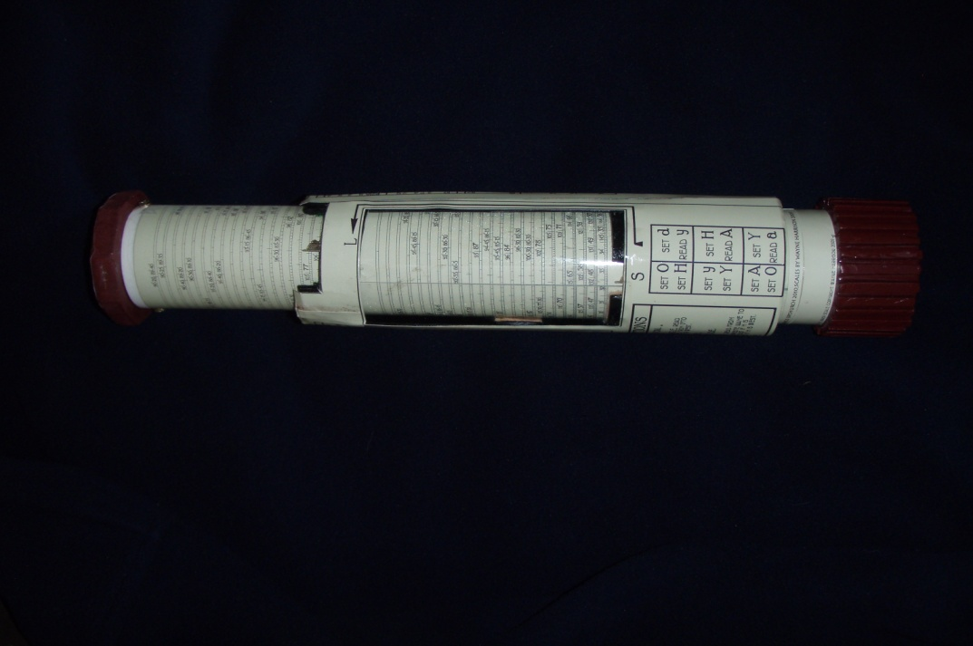

Summary of the building process.)
My skills are limited to a very basic arts and craft level. I am not a skilled instrument maker, have very little maths and rely on other brains for the dark arts of computer generated slide rule scales.
So the process for me was as follows:
- Obtain computer generated scales that can be resized in a computer and printed on high quality photographic paper on a reasonable quality printer. For my first prototypes (several versions) I obtained generous help from Gary LaPook, G Kolbe, R. Van Riet and Zvi Doron .
- Obtain precision made plastic tubes of roughly the correct sizes. I was lucky to find small scrap “off cuts” of PVC drain pipes, at virtually no cost. They fitted well together and were close to the dimensions of the original, which I used as a template.
- Download PDF high quality images of the scales into image editing software (I had Photoshop Elements 7.It can produce multiple, tiny changes in size. )
- Resize to the circumference of the tube and perfect by repeated trial and era, eventually obtaining scales of exactly the correct size to fit the tubes.
- Print the scales at highest quality on photographic paper.
- Cut the scales to obtain exactly the correct size. I used a scalpel to cut the paper along a steel rule against a wooden kitchen chopping block. This required repeated attempts by trial and era. It has to be perfect.
- Place a line of double sided scotch sticky tape along the length of the plastic tube where you want the “join” of scales to be. (Practice first without the tape and mark with a pencil ).
- Very carefully wrap the scales paper around the tube. When everything is lined up perfectly, press the edges of the paper together over the sticky tape. Press and smooth down. This is tricky and it took me several attempts by trial and era. Once stuck correctly, I found the paper is firmly bound by just the double sided tape and requires no other glue.
- Stick strips of felt, again using double sided tape to, the four quarters of the inside surface of the tubes to act as a “friction clutch” against the outer tube. This is again done by trial and era to get exactly the right degree of friction to allow smooth rotation but absolutely no possibility of accidental slippage during operation. This is a very important point and was probably a fundamental design flaw of the original Bygrave. The German copy of the 1940s had a locking mechanism to prevent slippage. My replica works perfectly and does not slip, but I need to service and replace the felt strips at regular intervals. I may add a lock one day.
- For my early prototypes, I photocopied the outer curser writing (non scales) from the original. This was fun, rolling the original tubes along the copier as it scanned along. This took several attempts to get it right. Do not try this for the scales. I did and found it virtually impossible to get uniformly accurate copies. Hence the need for computer generated scales. My later, authentic replica used computer generated writing by Wayne Harrison.
- The outer tube was made by wrapping clear plastic overhead projector slide material around hard plastic rings of the correct diameter. The photocopied writing was then stuck on with double sided tape. Felt strips were added to provide the necessary smooth friction.
- Add end pieces to the tubes. I used plastic coffee jar tops for my early prototype and made wooden copies for the replica.
- Stick small brass cursers at S and L on the inside of the outer tube. I used old disused keys, filed down to the correct shape and size. Positioned by trial and era and stuck with superglue.
- I used “Plastikote” clear plastic spray paint to protect, seal and waterproof the scales and outer tube.
- Have a well deserved celebratory tipple. (small one or you may get lost below).
- Practice reducing some sights and be amazed at the accuracy compared to a calculator. I was. With practice, I find the Bygrave almost as quick and accurate as a calculator and a lot more fun.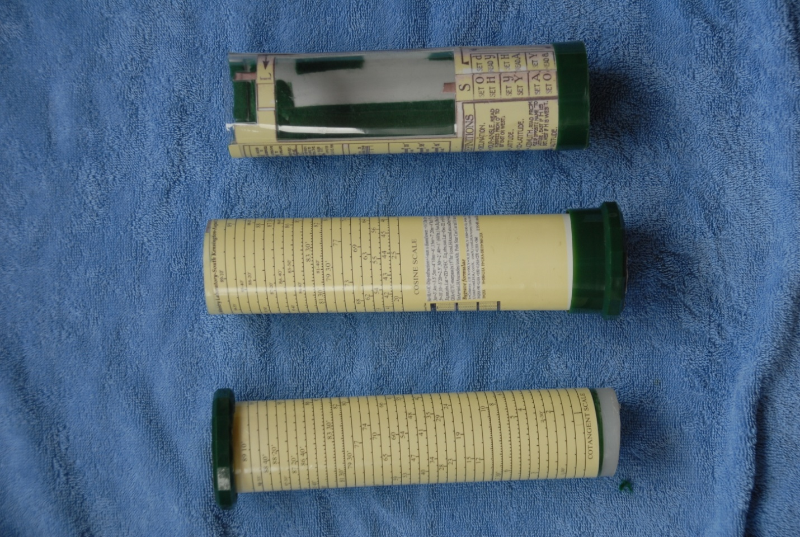
Early prototype. The outer tube carrying photocopied writing from the original, the 2 inner tubes scales by Gary LaPook.

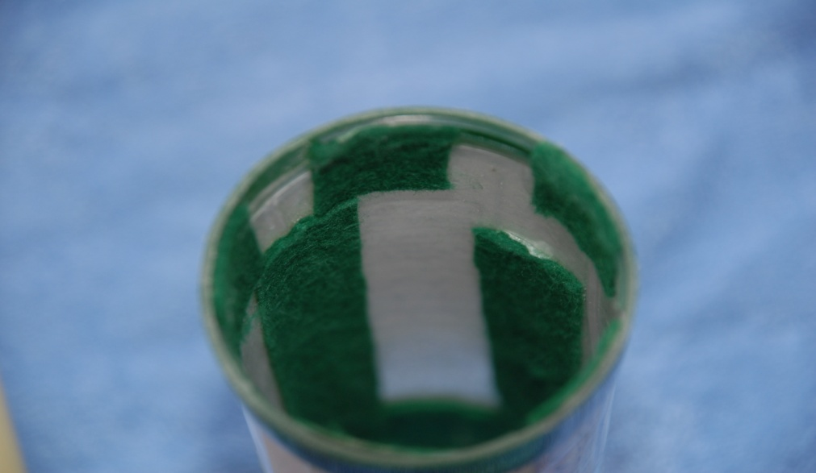
Felt friction strips stuck to inside tubes with double sided tape.
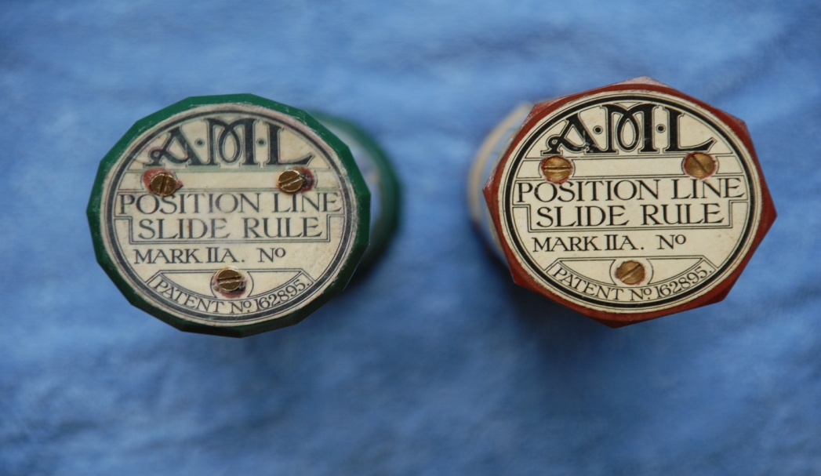
Authentic end pieces photocopied from original (on the right)
Other slide rules
The Fuller cylindrical rule has a spiral scale up 42 feet long and therefore has an accuracy from 5-7 decimal places. It basically gives similar results to a modern calculator, but takes a little longer. I was privileged to inherit my grandfather’s Fuller 1, vintage 1920s, in perfect condition despite regular use (engineer). Too precious for the seafaring life, and without trig functions, I built a Fuller 2 replica (with sine functions), courtesy scales from Wayne Harrison. The process was the same as that described above for the Bygrave. The long brass cursers were obtained from a hardware shop. They can be adjusted with small conical screws to obtain perfect alignment. This rule is accurate to 5-7 decimal places and can be used for navigation. (I use it to clear lunar distance sights). However, it is too bulky and the cursers too vulnerable for life at sea, so I prefer the Bygrave. I am working on a smaller version, using similar tubes to the Bygrave, for a “general use” accurate, sea worthy slide rule. (watch this space).
My slide rule collection. From top: Grandad’s Fuller 1, homemade replica Fuller 2 (Wayne Harrison scales), original Bygrave 11A circa late 1920s, providence unknown (no serial number) but perfect working condition. Homemade replica Bygrave 11A,(scales Wayne Harrison), first homemade Bygrave (Gary LaPook scales). Original Otis King circa 1960s. ( 4 feet scales, better than linear but not good enough for navigation). My Thornton 10 ‘school- boy slide rule from 1960s. The beginning of a passion. The blue plastic protractor is not a slide rule, but my cheap nocturnal for measuring Polaris correction. (details on request. It works!)
