# File: 3COP.obs

|  |  |  |  |  |  |  |  |  |  |  |
| --- | --- | --- | --- | --- | --- | --- | --- | --- | --- | --- |
|  | d | m | y | h | m | s | Body | Dec | GHA | Ho |
|  | 5 | 10 | 1970 | 18 | 24 | 36 | Arcturus | 19.335 | 166.829 | 22.2 |
|  | 28 | 9 | 1970 | 19 | 47 | 24 | Vega | 38.758 | 115.277 | 70.15 |
|  | 28 | 9 | 1970 | 19 | 40 | 12 | Dubhe | 61.909 | 226.98 | 20.35 |

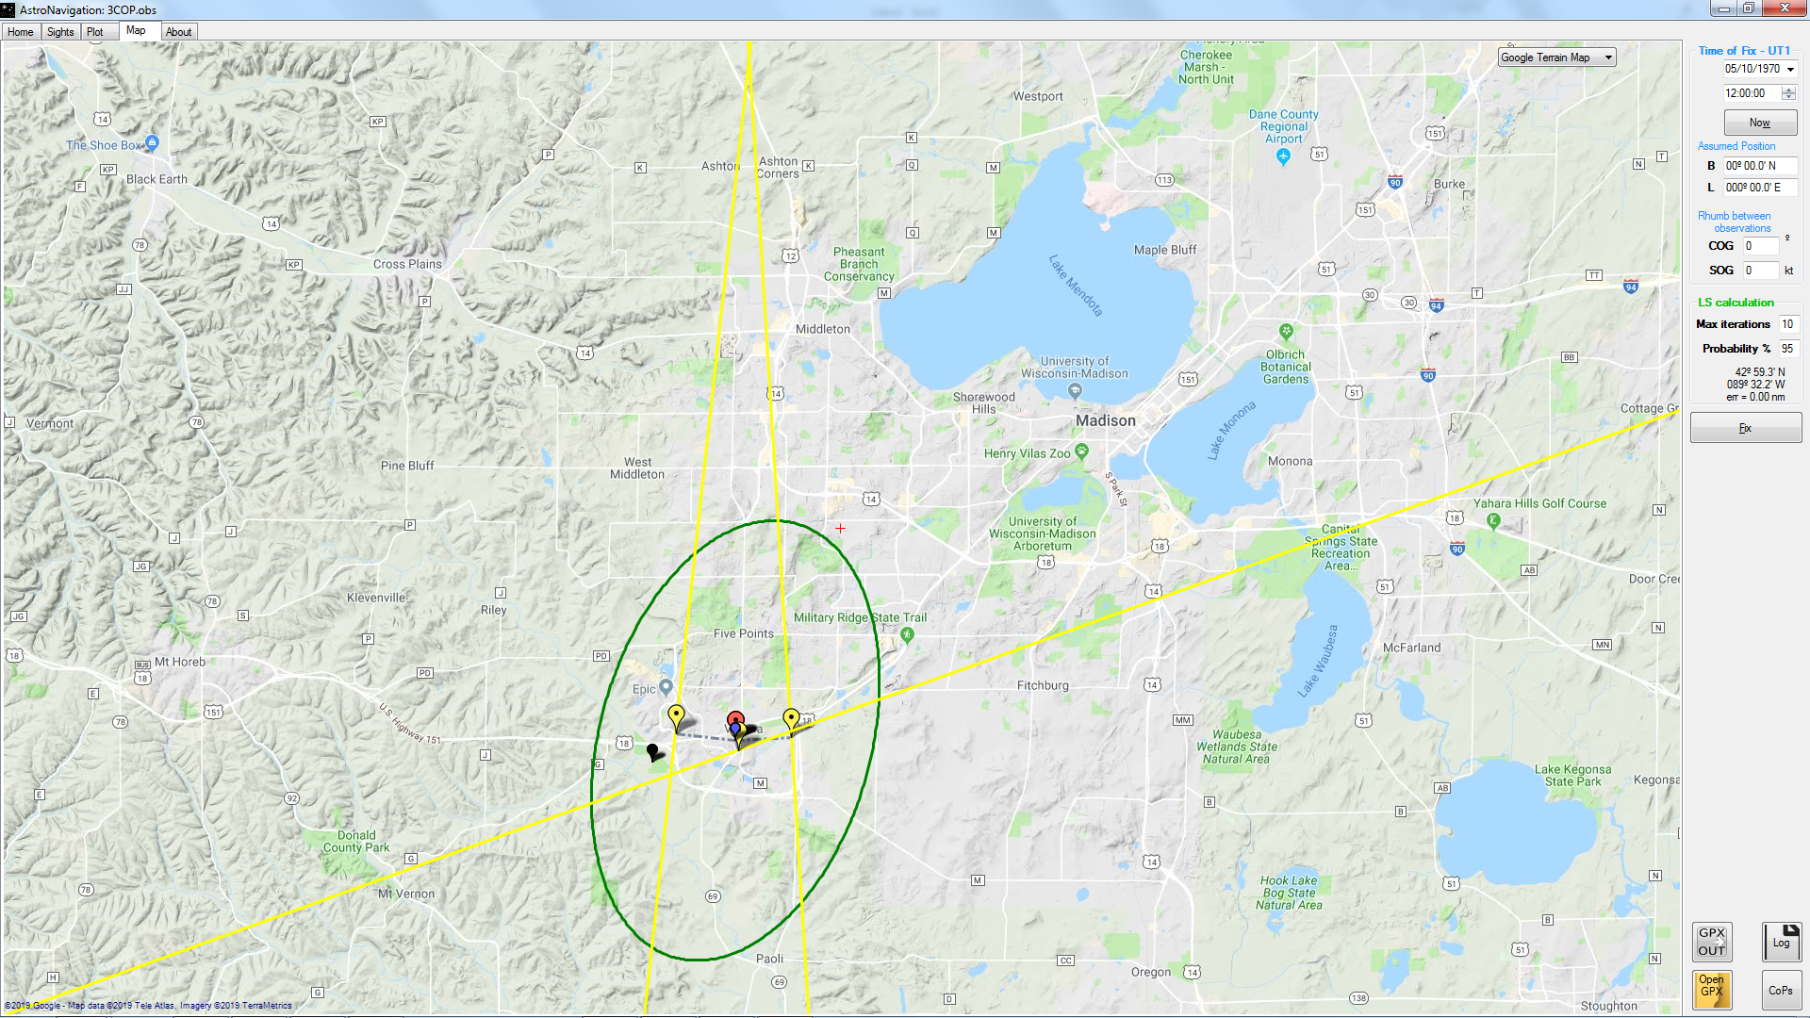

|  |  |  |  |  |  |
| --- | --- | --- | --- | --- | --- |
| BO | LO | LHA | HC | Z | p |
| 42.9878 | -89.5363 | 77.2927 | 22.1841 | 276.2412 | 0.0159 |
| 42.9878 | -89.5363 | 25.7407 | 70.1648 | 266.4526 | -0.0148 |
| 42.9878 | -89.5363 | 137.4437 | 20.3528 | 340.1436 | -0.0028 |

42º 59.3' N 089º 32.2' W

# File: P34.obs

|  |  |  |  |  |  |  |  |  |  |  |
| --- | --- | --- | --- | --- | --- | --- | --- | --- | --- | --- |
|  | d | m | y | h | m | s | Body | Dec | GHA | Ho |
|  | 6 | 7 | 1996 | 20 | 39 | 23 | Regulus | 11.984093 | 82.904835 | 24.923982 |
|  | 6 | 7 | 1996 | 20 | 45 | 47 | Antares | -26.423201 | 349.247609 | 27.012054 |
|  | 6 | 7 | 1996 | 21 | 10 | 34 | Kochab | 74.17603 | 20.084312 | 47.393896 |

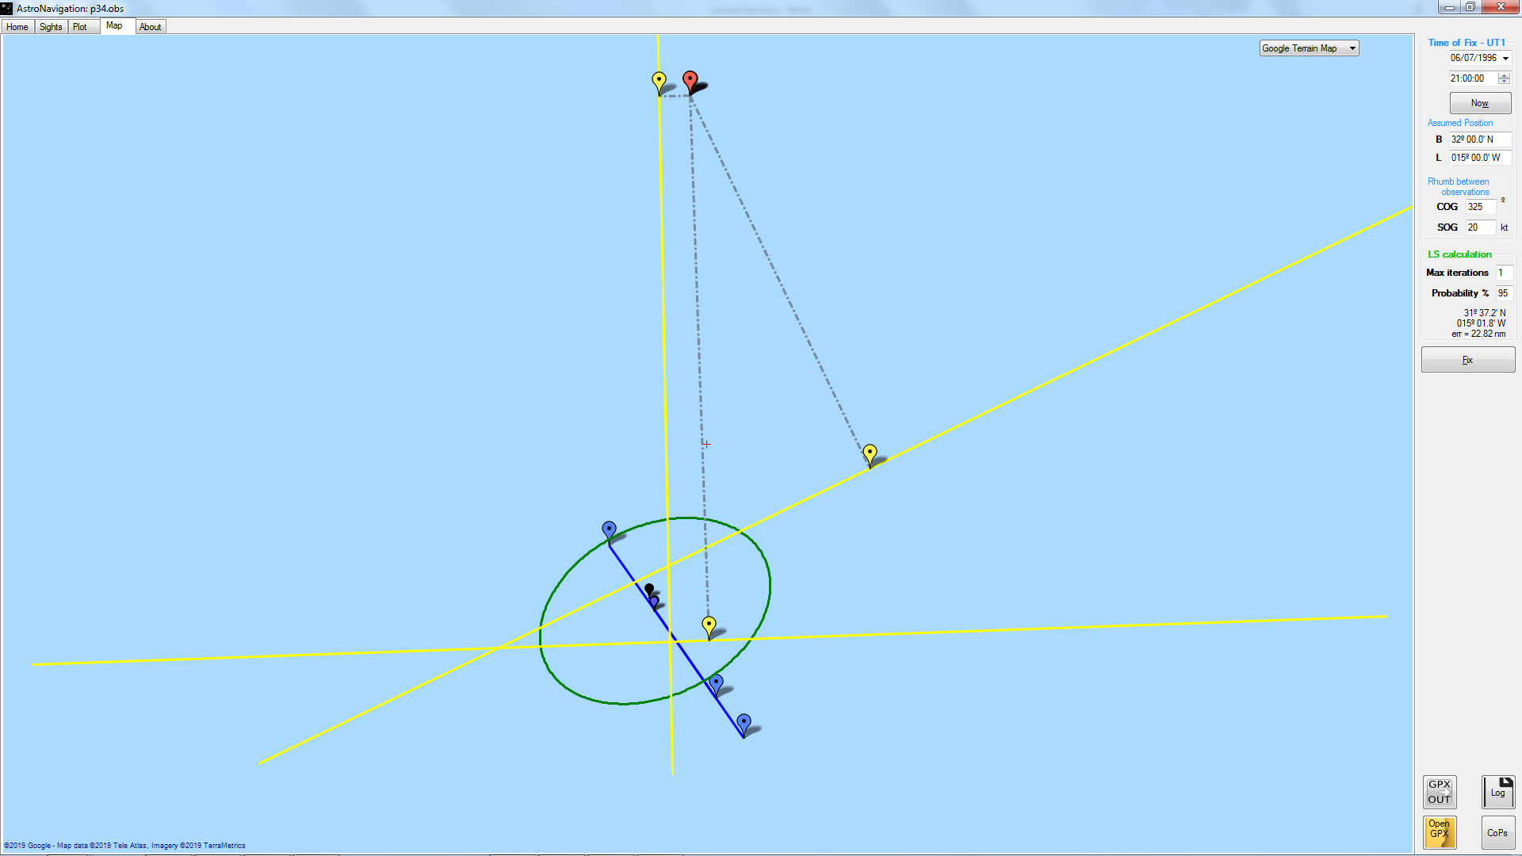

|  |  |  |  |  |  |
| --- | --- | --- | --- | --- | --- |
| BO | LO | LHA | HC | Z | p |
| 31.9062 | -14.9225 | 67.9823 | 24.9015 | 268.891 | 0.0225 |
| 31.9353 | -14.9466 | 334.301 | 26.707 | 154.2326 | 0.3051 |
| 32.0481 | -15.0397 | 5.0446 | 47.7956 | 357.9545 | -0.4017 |

31º 37.2' N 015º 01.8' W

=

# Fix by 3 Brg

