Royal Institute of Navigation East Midlands Branch
The East Midlands Branch is a small friendly group who meet or arrange visits up to twelve times a year. Membership generally covers the area from south of the Humber to north of the southern tip of the Wash and from east of the Pennines to the North Sea, but nothing is set in concrete.
Evening meetings usually take place in Room A19 of the Nottingham Geospatial Building, University of Nottingham Innovation Park, Triumph Road, Nottingham, NG7 2TU on dates set out in the RIN annual programme, Navigation News and in the events sections of the RIN website. Visits are also advertised in the same way. Evening meetings usually start at 7.30PM and tea and coffee is available from 7.00PM.
Our policy is to attempt to cover all aspects of navigation during the year including land, air, sea, and space at a level which can be followed by all. Our biggest event each year is to organise a History of Air Navigation Day called HANG North.
Our Branch Chairman is Steve Hogarth and our Branch Secretary is David Pike. Both may be contacted via emids@rin.org.uk .
We are always ready to welcome new members and guests, and we would also be interested to hear from people who would be prepared to talk to us at our meetings or invite us for visits to their establishments.

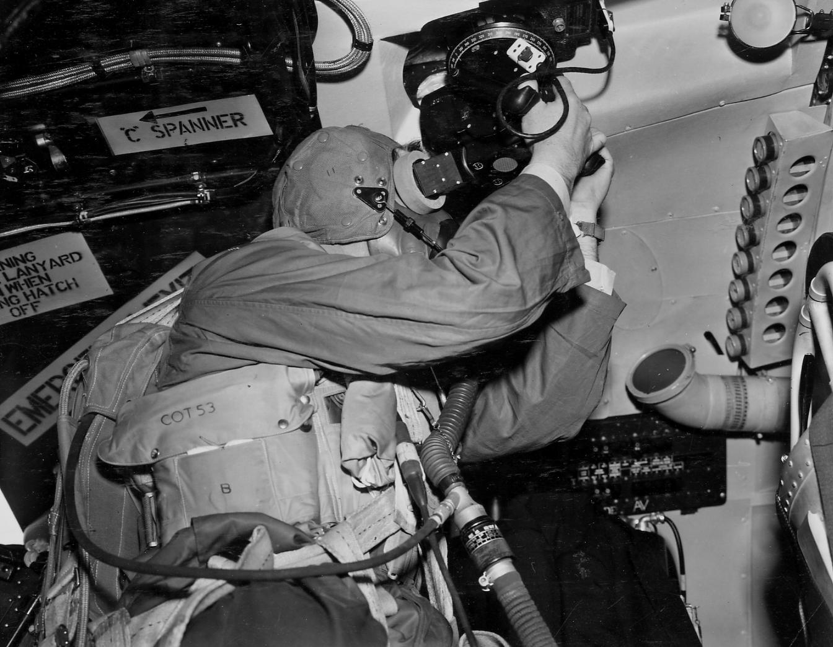
I Shot the Sun
With the Royal Institute of Navigation

at the Tribute to the V Force Day
Newark Air Museum
19th May 2018

