DOES THE RIN NEED AN ASTRO-VAN?

RIN Astro-Van No1 Mk1

In writing this letter I’m prompted by two thoughts. First, Channel 4’s recent programme with Tristam Gooley shows that since its demise and the introduction of GNSS, which is only a build your own star system. Astro navigation, which was always considered a black art by the uninitiated, is achieving renewed fame as being absolute magic. Secondly, it’s difficult for the East Midlands Branch to find items which might attract the general public and youngsters in particular to practical navigation. It’s not so bad near the South Coast and around the major seaports which have nautical institutes, because they have companies producing on-board navigation equipment, ship simulators and similar which can be borrowed. Although the East Midlands and Nottingham in particular is a centre of excellence for GNSS research, the output is invariably to a computer screen, which is great for the computer buff but doesn’t always suit the more ‘rule of thumb’, ‘hands-on’ sort of person.

My aim is to give our visitors something to handle and try out while at the same time demystifying astro. The problem is, whilst a nautical sextant might be ideal for a south facing promenade on the South Coast, we don’t have many of those in the East Midlands. An aircraft bubble or pendulous reference sextant would be better, but the WW2 hand held sextants like the ubiquitous MarkIX are now so dirty inside you can barely see the sun, let alone the stars. They are also getting very stiff to operate, so we are left with the Kollsman and the Smiths periscopic sextants of which I have working examples. However, to use them properly you really need a mounting of which I have only one rescued from a Dominie.

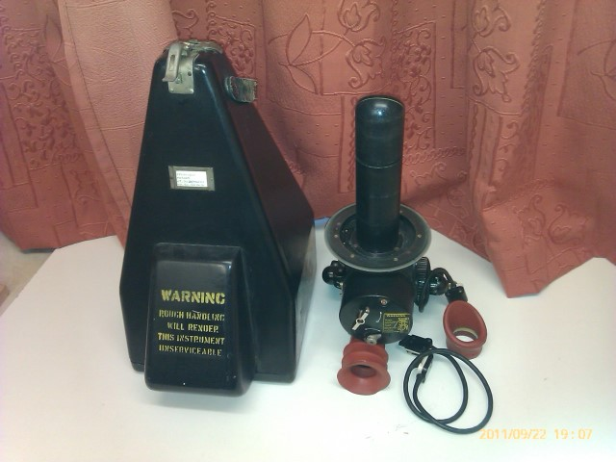
Smiths Periscopic Sextant Mk2B

The next problem is setting up the facility. The sextant stands which once graced RAF training establishments have all mysteriously disappeared, and they wouldn’t fit into a car in any case, so I started to think about a tall trailer or horse box. Unfortunately, the longest, clearest nights for astro occur between November and March, and neither of the above would be very warm or inviting. Then I thought what about a caravan. You can buy a tired 12ft caravan for less than £500. Often the price is lower, because the roof lights need replacing. That wouldn’t worry us, because were going to remove them to fit the sextant mountings. The crew could sit inside in the warm, brewing up if necessary, while working out astro with AP3270 at a desk inside. If a long way from home, you could also sleep in the caravan saving hotel fees. The addition of an astrodome, if we could find one, would also allow demonstration of the use of an astro compass for taking heading checks and bearings on distant features. If we couldn’t run to such sophistication, a circular hatch and a hand-bearing compass would have to suffice.

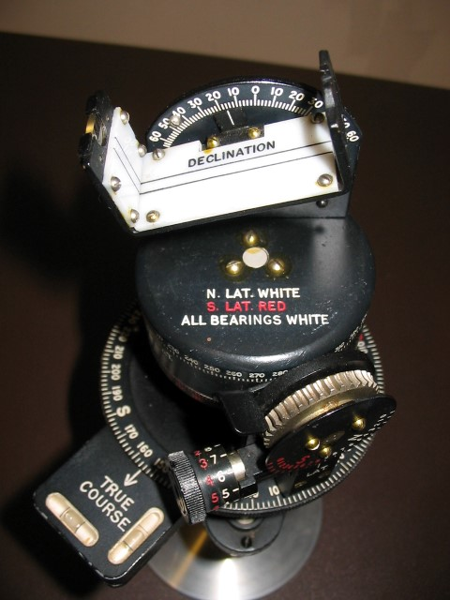
Astro Compass MkII

Once set up, the caravan could be towed to any venue which offered the opportunity to make good use of her (Do you call astro-vans her?). We might even persuade the current companies to display examples of there latest gear inside (suitably bolted down). My shopping list is: Essential: an old 12ft caravan, and a current decade AP3270 Vol 1 Red Band, Desirable: a mounting for a Kollsman periscopic sextant, an astrodome, and a mounting for an Astro Compass MkII. What do people think?

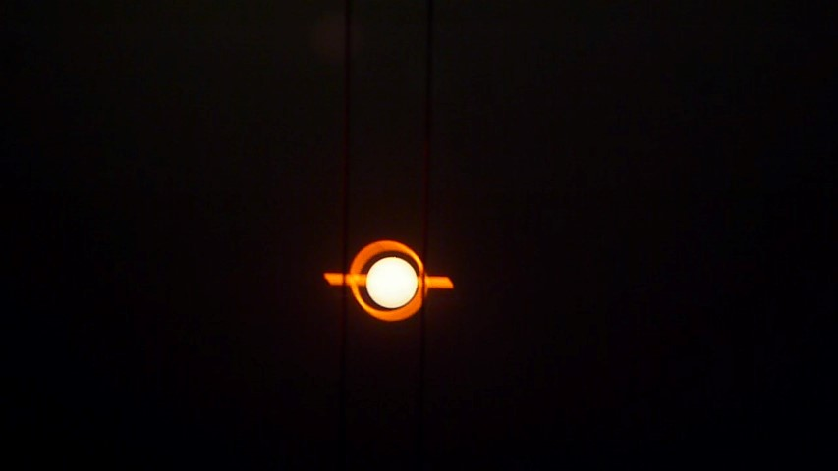
Steady for Astro

Dave Pike FRIN
Secretary RIN East Midlands Branch
emidlands@rin.org.uk

