The Astrovan Cometh

As hobbies go, collecting and using sextants, especially aircraft sextants, is probably one of the tamer ones. However, the hobby does produce its own particular problems. The first is how to hold your sextant. From the late 1930s, most aircraft sextants were designed to be hung from a hook in an astrodome or supported within a mounting installed in the aircraft. You can hold them with both hands alone, but they soon begin to get heavy, especially the periscopic ones, and it’s difficult to keep the bubble or pendulous reference steady.

One way to overcome this problem is to choc up your sextant on the window ledge of a nice warm room and observe from indoors. However, one’s field of view will be severely restricted, and the refraction correction for your double-glazed window will be unknown. A hardier solution is to hang your sextant from the top of a tall step ladder in your back garden or balance it on the top platform. Either method risks subjecting your sextant to the 6ft drop test or a night in A&E with a broken leg.

Even if you find a satisfactory solution to the mounting problem, an even greater problem when observing from home is light pollution. With a 1960s periscopic sextant, only the brightest stars will be visible. With a 1940s bubble sextant, you won’t see much more than the Sun, the Moon, and the brightest planets.

Clearly, mobility is also required along with a nice warm cabin to work from. A van might suffice, but it would require tax and insurance, probably some careful tin opener work on the roof, and it wouldn’t be insulated. How about a caravan? A caravan would be insulated; it would have a heater for night work, a stove to make a cup of tea, roof hatches to modify to take the sextants, room for books, a table to work on; and it wouldn’t need to be taxed or insured separately. The essential criteria were laid down. We required a caravan costing less than £500; with at least two roof ports; with a flat roof to make carpentry easy (a big mistake as it turned out); and small enough to be moved by two pensioners and towed by a 1.4 litre petrol engined car.

Finding anything to fit all the criteria, especially the less than £500, took almost two years. Eventually, we spotted an advert in our local supermarket for a caravan that seemed to fit the bill for just £475. When I rang the vendor, he said it had just been sold, but that he had another one in a field in Cornwall that he would be bringing back for sale in Lincoln in about 6 months time. We agreed he would ring me when the caravan arrived, and sure enough, six months later the vendor rang me to say the Cornwall caravan, a 1980(ish) ABI Marauder D400, was now back in Lincoln and ready for inspection, but that I’d better be quick, because another person was due to look at it that evening. I hurried to his house and found that despite being nearly 40 years old, it was quite good outside and almost new inside, so the sale took place. When we’d arrived, the caravan door was already open, “to give it a little air”, the vendor said (Caution! but more of this latter).

My first short test drive went fine until I tested the overrun brakes and found one brake was binding on. By the time we arrived home, that wheel hub was sizzling hot. However, it proved the car was capable pulling it and I could drive it. Matching up 40-year-old brake cables would have been difficult without the aid of Google, but eventually a new pair was found and fitted. At the same time, I renewed the tyres, which although they had virtually no wear after 40 years, were full of tiny cracks due to exposure to sunlight.

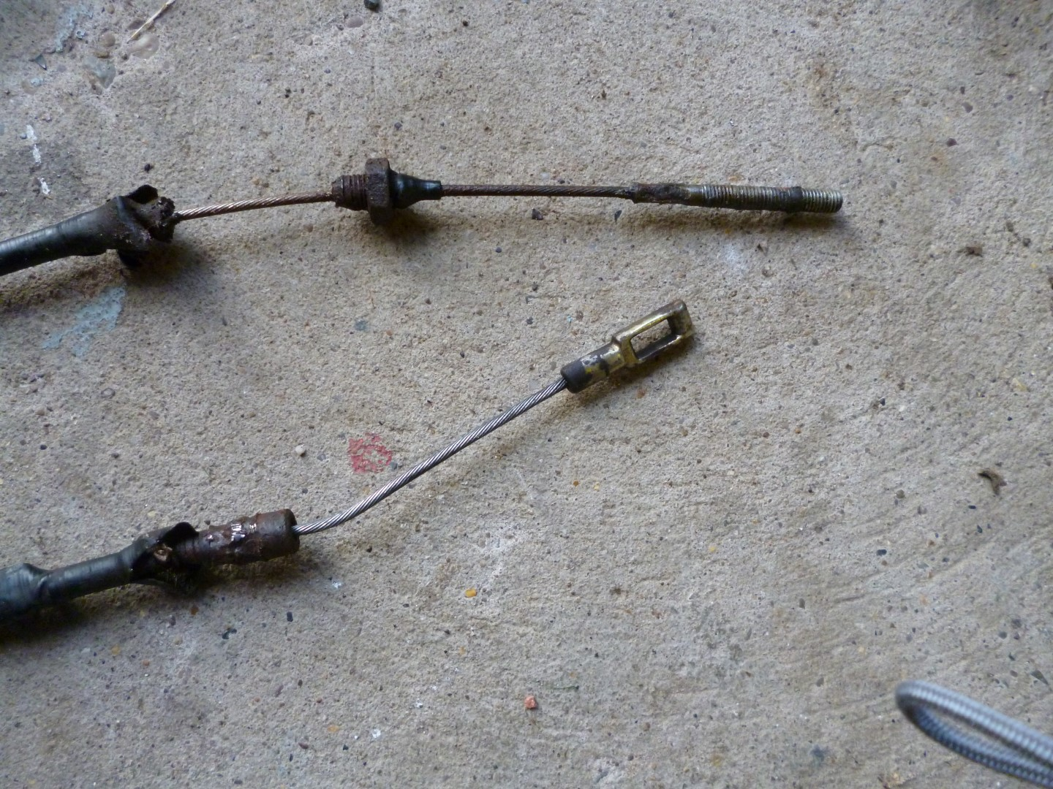
No wonder the brakes were failing to release (DP)

The next item for attention was the heater. It certainly didn’t work, and the previous owner said he’d never used it, being always connected electrically. Then one day after we’d been happily trying out the gas cooker, I went outside to turn off the gas bottle and could hear gas escaping under the caravan. It turned out that the gas supply went through a simple tee junction to the cooker and the heater, and the steel supply pipe of the heater (required in Germany apparently) had completely rusted away at its bottom end, so that gas was blasting out straight from the copper supply pipe to the atmosphere. It soon appeared that most of the ‘used’ heaters for sale on-line were little better than our own, so I decided to mend the heater myself. A gentleman near Nottingham was able to supply me with most of the bits I required ex-works; the remaining rusted rods etc I manufactured myself from stainless screwed rod.

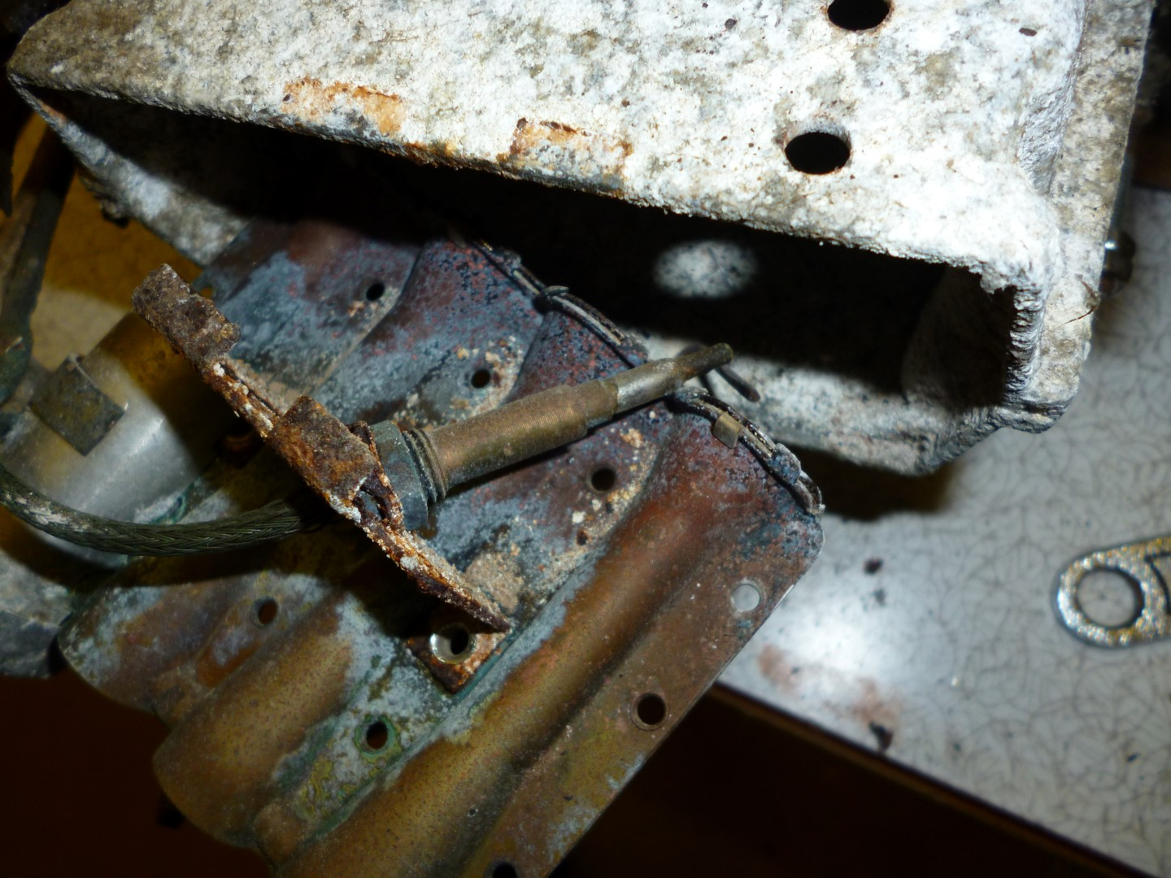
The heater need rather more work than anticipated. (DP)

That brings me to “the smell”. Within a couple of days of purchase, the area around the caravan took on an aroma, which all the perfumes of out local supermarket couldn’t sweeten. However, when I removed the heater and took it indoors for servicing, “the smell” came indoors too. The inside of the heater is a bit like a saxophone though which heated air circulates before venting to the atmosphere. After much tipping upside down, about a pint of farmer’s wheat, the sort that’s dyed red, fell out of the heat exchanger along with chestnut shells and various other bits of debris. Some little animal must have crawled up there and made a nest and food store. With all that gone, the “the smell” disappeared.

It soon became clear that a flat roof for ease of carpentry wasn’t such a good idea. Rainwater pooled on the hatch tops and soon started finding its way down the sextant mounting tubes. The answer was to build bunds around the sextant tube holes and cover them with a pair of smaller hatches held down with bungee elastic. Also, the mounting hatches no longer provided long term ventilation inside the caravan, and this was only overcome by removing the sextant hatches when not in use and replacing them with the original roof vents.

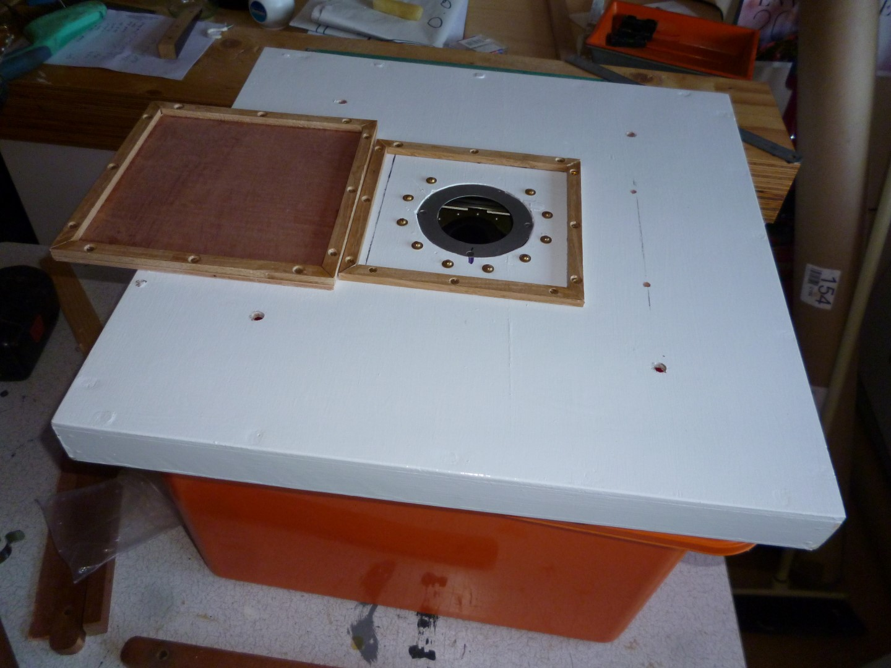

The hatches needed bunds to protect from rain puddles (DP)

Eventually, we were ready to start observing. We already had AP3270 Vol 3, “the Yellow Band”, and we downloaded the current USNO Air Almanac and the USNO HO249 Vol 1 pages for 53N free from the internet. To check our calculations, we used ‘Navigator’ celestial software although we soon started using just ‘Navigator’. For night work, we fashioned a flexible work lamp using a red led torch.

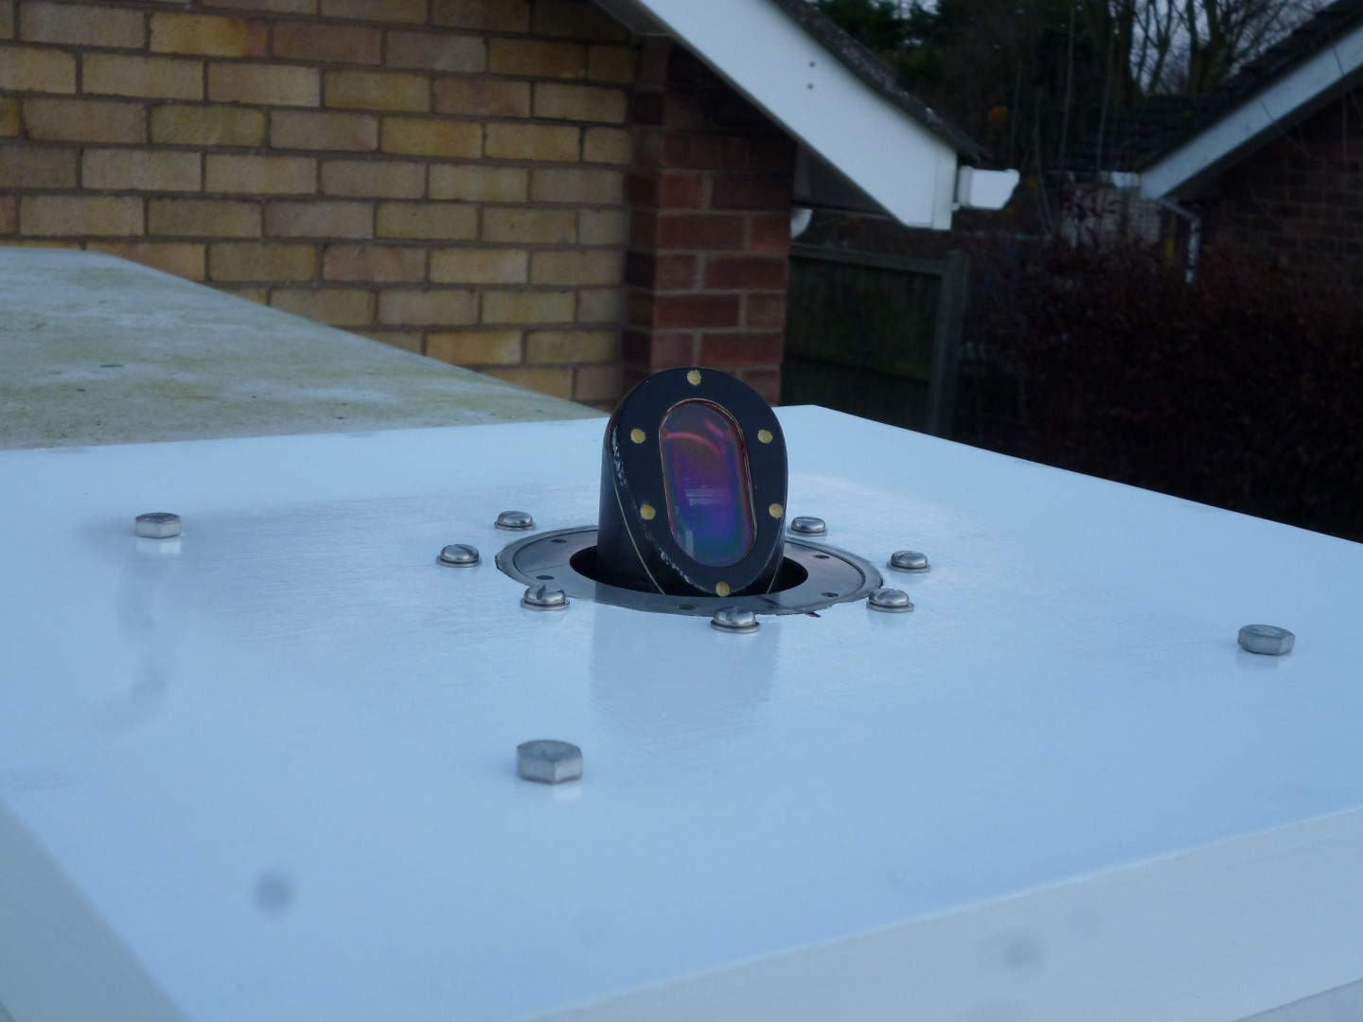
Somebody is watching you! (DP)

Initially, we mounted a 3-volt Kollsman periscopic sextant over the kitchen area. The smaller roof vent was over the loo, so we chose a Smith’s Mk2c sextant for this position, because the swivel eyepiece enabled us to make maximum use of the restricted space available. To allow use of hand-held sextants, we adapted the two sextant holding hatches, so that both periscopic sextants could be used over the kitchen vent, and we made a cantilever to mount over the loo vent. Then we hung a MkIX sextant from the free end of the cantilever.

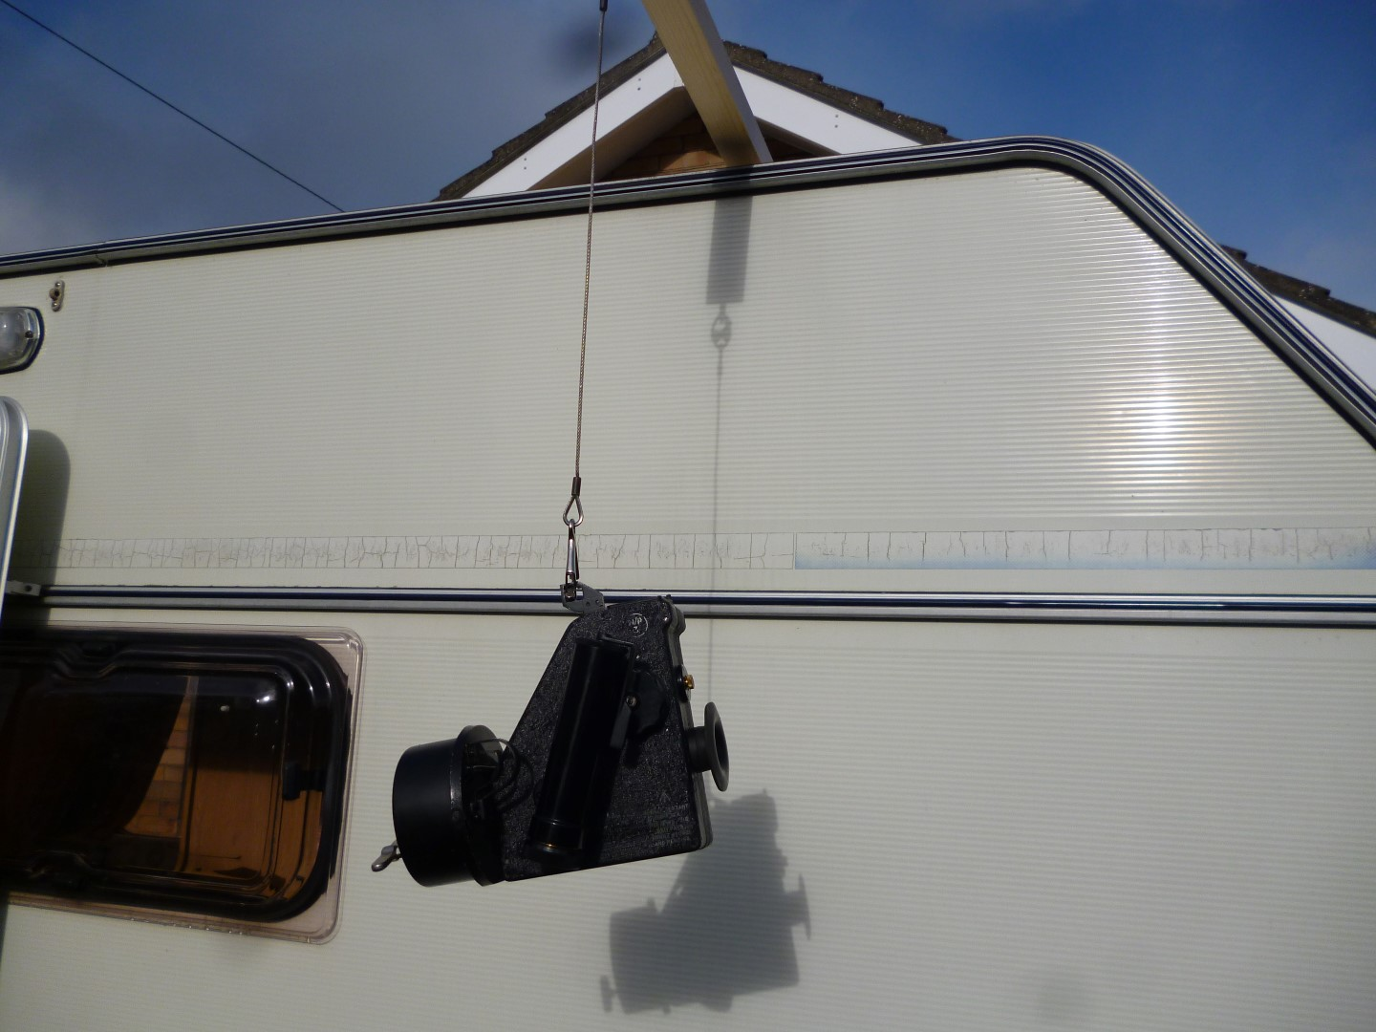
The MkIXA sextant support (DP)

Techniques gradually improved and with DP doing the observing and JGP doing the timing and recording we got about as close as we’re ever going to get to working in an aircraft.

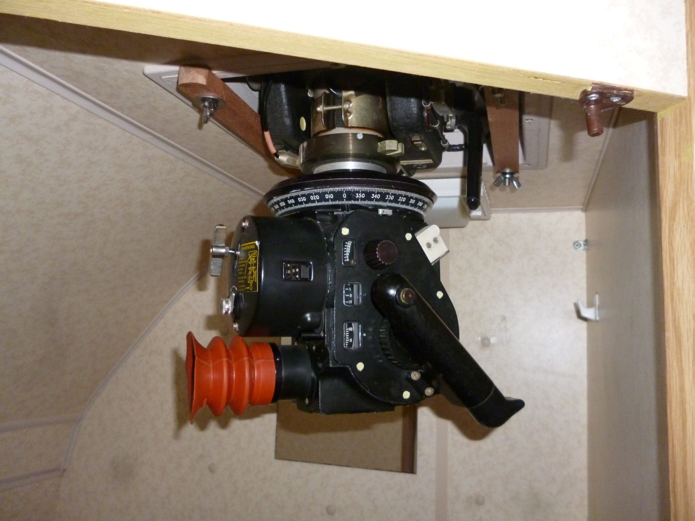
A Mk2B in the loo. Not quite the ‘black hole’ of a Vulcan but near enough (DP)

We soon wanted to introduce the Astrovan to others, so we took the Astrovan to the Shackleton/Hastings weekend at Newark Air Museum in June, where we allowed several visitors to shoot the Sun. Our next astro outing was to the History of Air Navigation Seminar at Newark in October, where to the consternation of the ‘experts’, one Museum visitor achieved 1.4nm away from his first ever instructed shot with the Mk2C. This was by far the best observation we’d recorded all day. Demonstrating to visitors is a bit like technical sales. You don’t get many people interested, but those you do get are very interested.

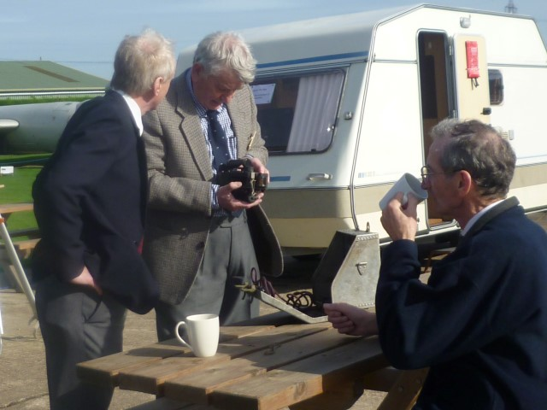
‘Antiques Road Show’ RIN Style (JGP)

Our ambitions for the future are an overnight outing to an area of low light pollution (if we can find one) and attendance at more special days at Newark Air Museum. The ‘Tribute to the V Force’ next May looks like a good bet.

D Pike 21Oct2017

